**Lab 1. Create the first report by using eFashion universe.**

1. Logon to Sap BO using your credentials.

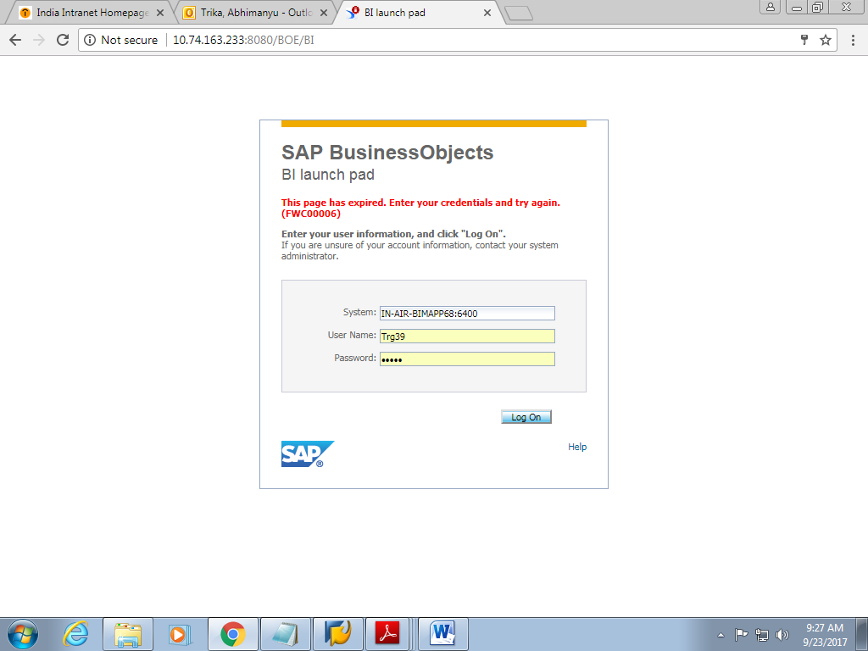

1. Click on Web intelligence.

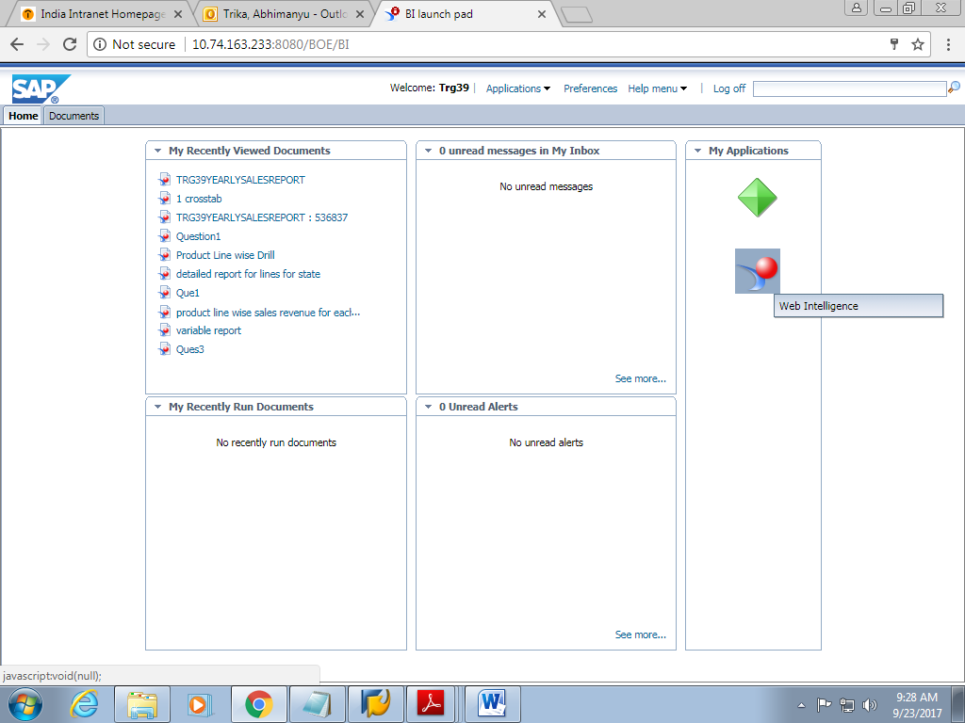

1. Now on the Web intelligence page, Click on new and then select Universe and click on Ok.

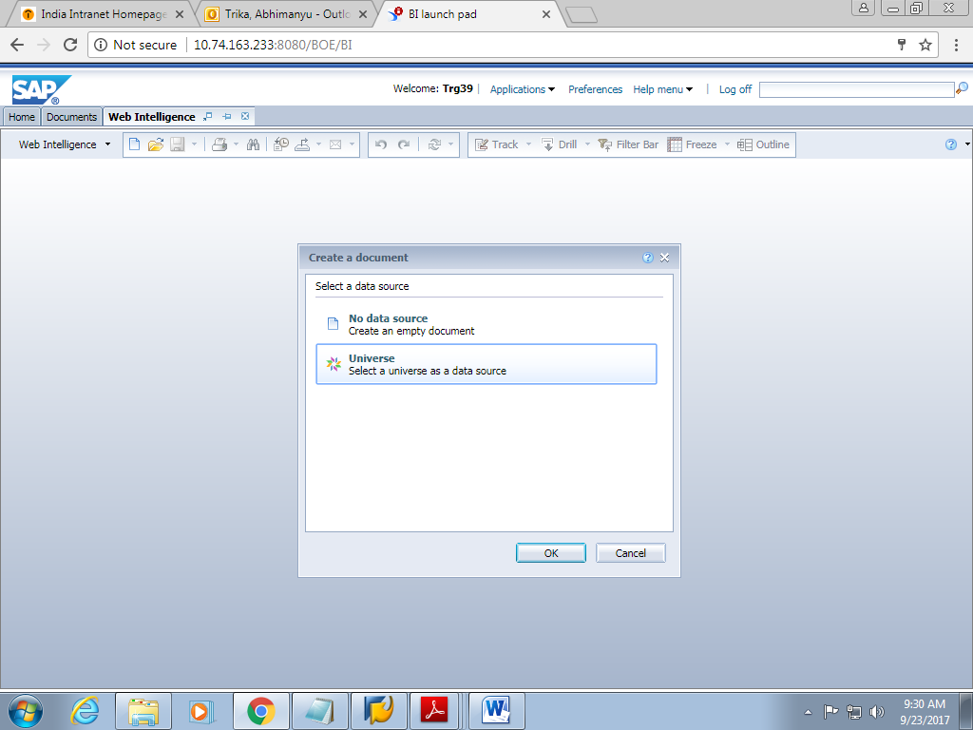

1. Now from the Universe list, Select the universe “EFashion”.

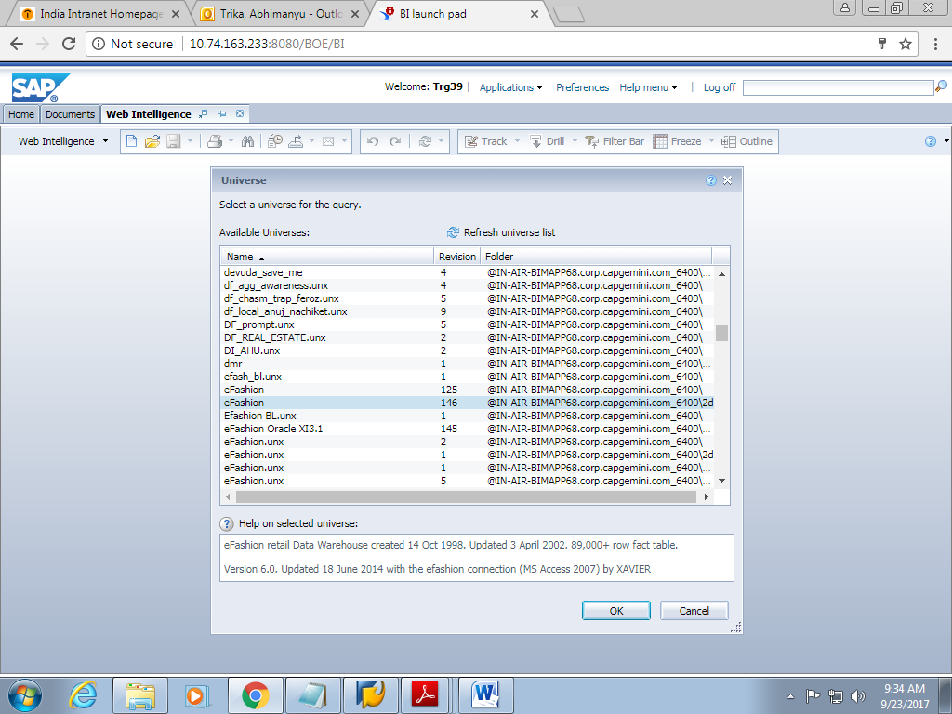

1. This opens a Query Panel where you can see all the objects provided by

eFashionuniverse.

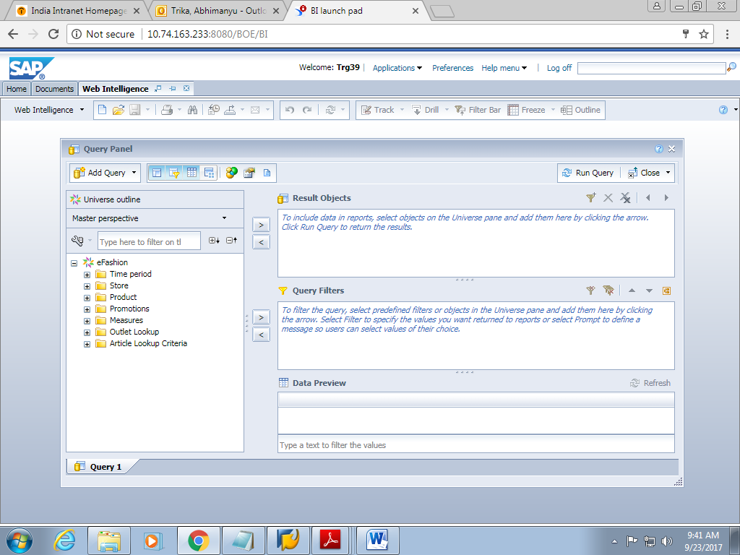

1. Choose the objects Year, Lines, Sales Revenue and Quantity Sold from the Classes and Objects pane and drag it the result pane and click on Run Query.

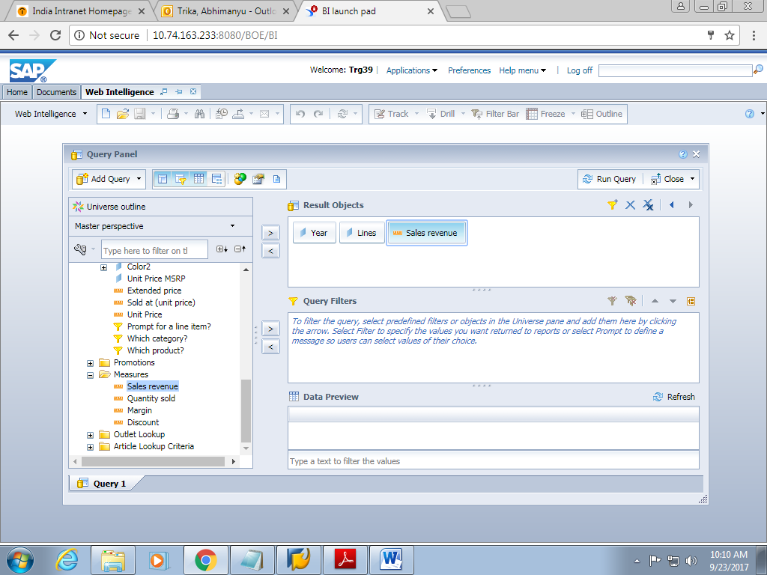

1. The output of the query will look like this. Also Change the title of the report.

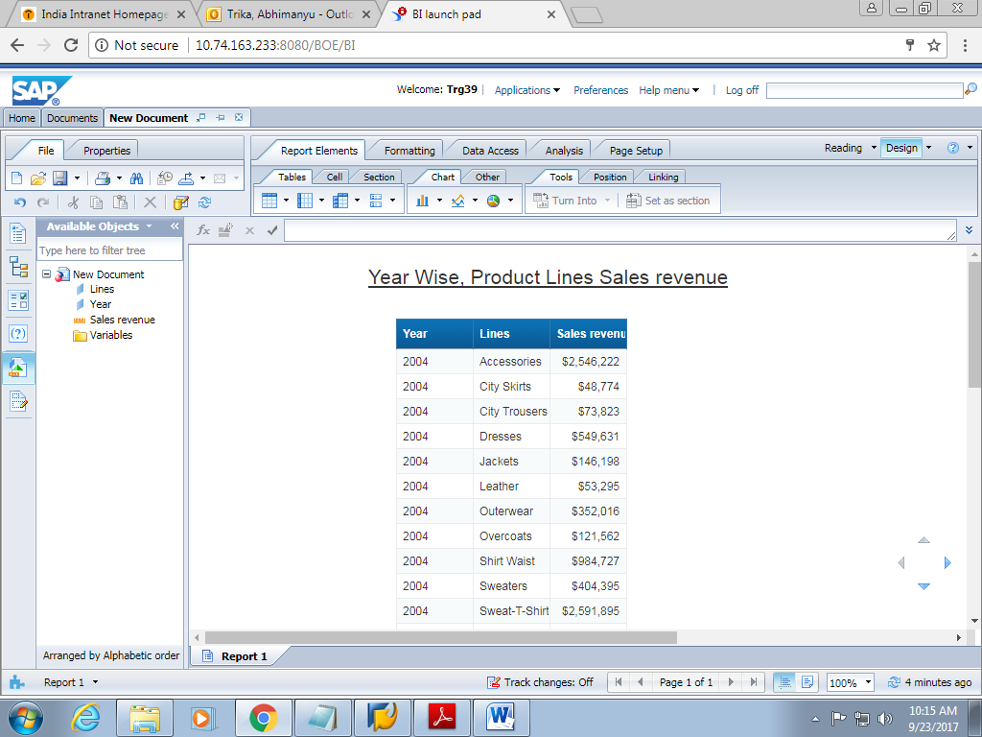

1. Click on **File -> SaveAs** and save the report as **Year Wise, Product Lines Sales Revenue** in the respective folder. In my case it is 19thJulySap39. Now Click on Save.

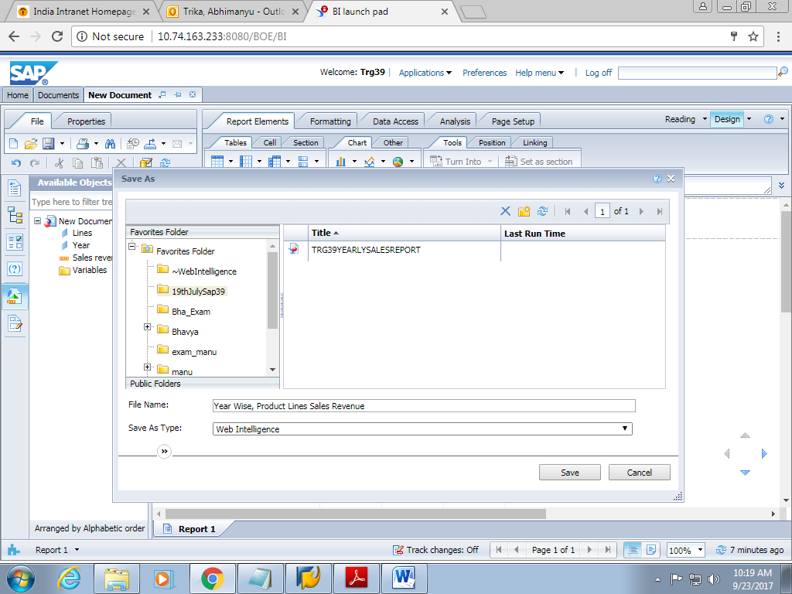

1. Now Log off the report.

**Lab 2.1 Creating Filters**

1. Logon to Sap BO using your credentials.
2. Now from the documents, select the folder and select the document Year Wise, Product Line Sales revenue and open it in modify mode.

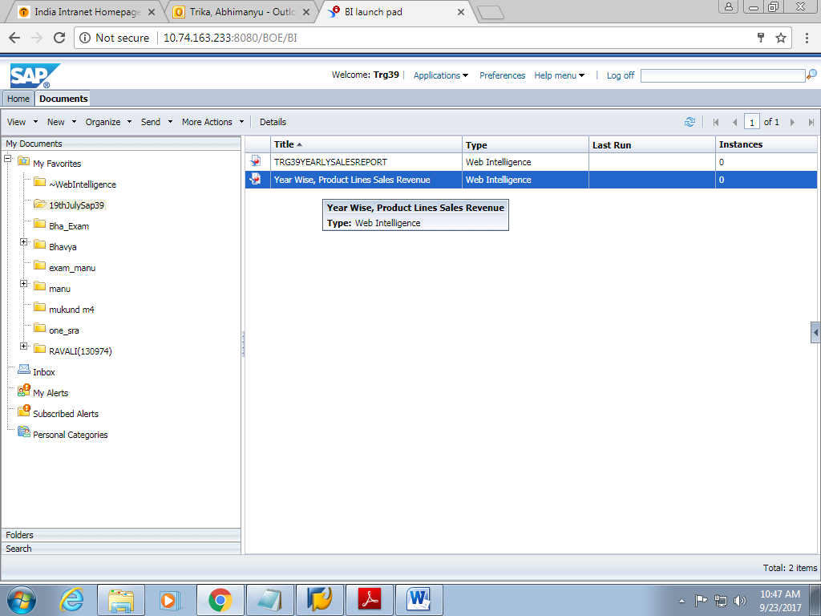

1. Click on Edit Query on the toolbar.
2. In Class and Objectpane, select Products \ Linesand drag it to Query Filterspane as shown in the figure given below.

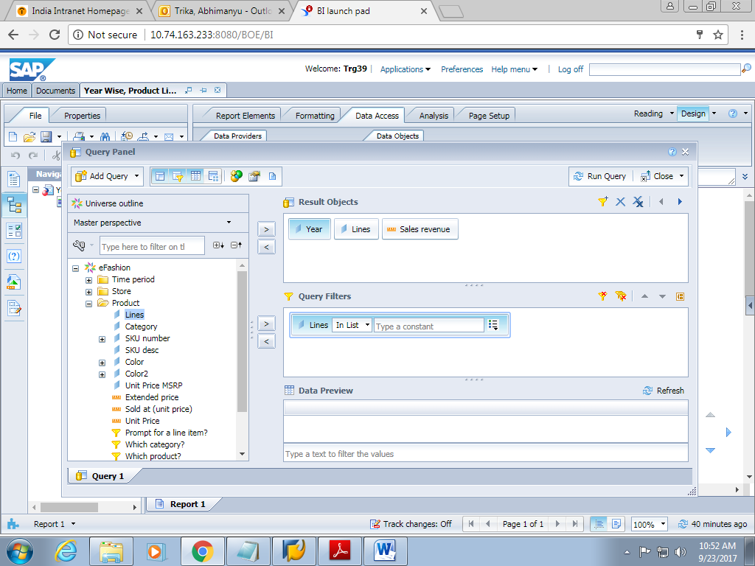

1. In the Query filter pane, click a small icon and select Value(s) from list for Lines.

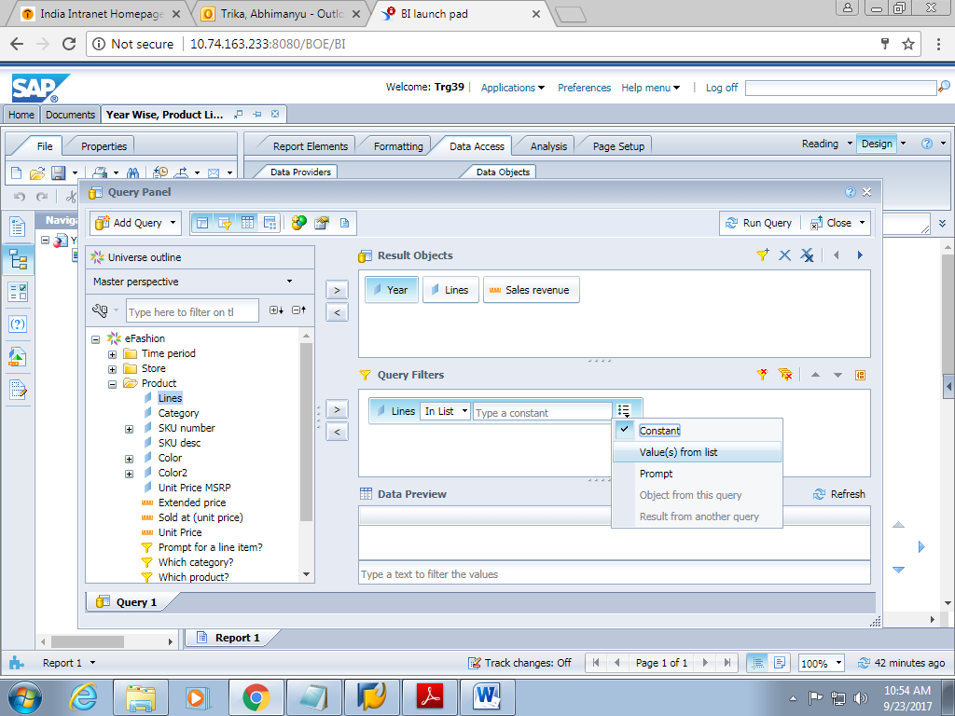

1. It displays a List of Values Select the option City Trousers for Lines. Click OK.

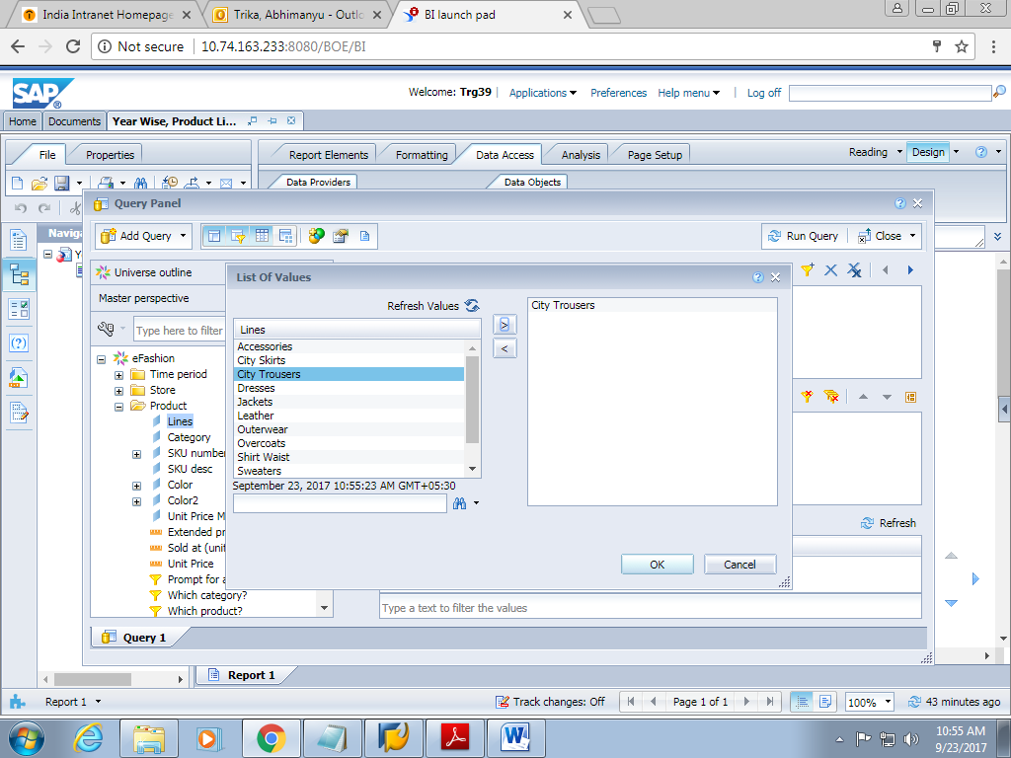

1. Click on run query and obtain the output as shown below.

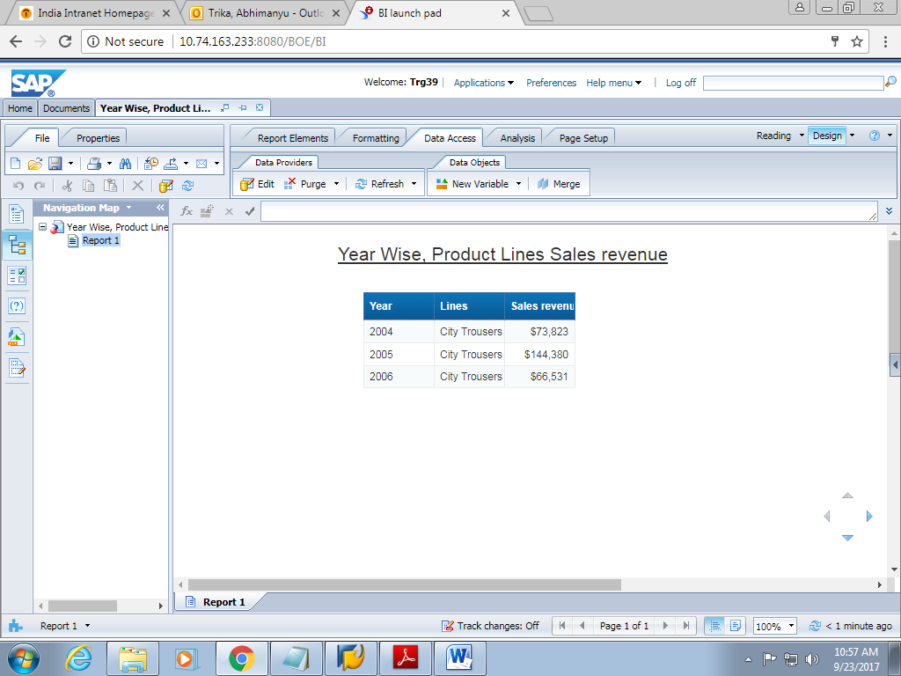

1. Save the document as “Year Wise Sales revenue for City Trousers”.

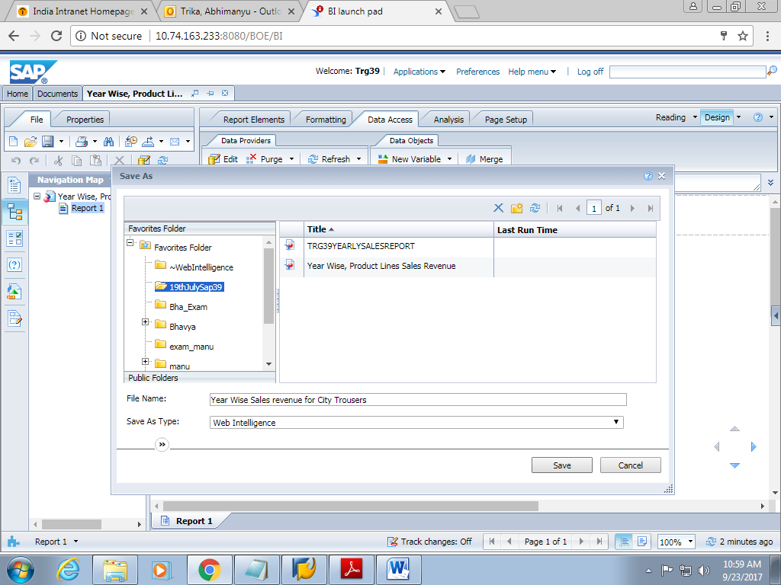

**2.2 Create report level filters.**

1. Click the YearWise**,** ProductLinesSalesrevenuedocument in the Modify

mode to view the data in Workspacepane. Select the Linescolumn, and click the Add QuickFiltericon on the toolbar as shown in the figure given below.

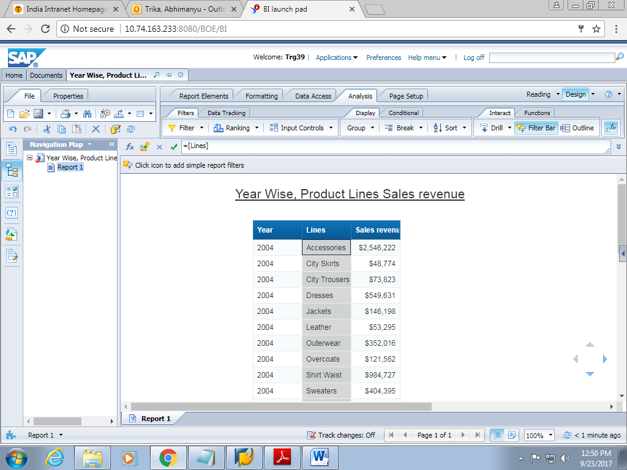

1. The List of Values dialog box is displayed. Select the value City Trousers and

click the OK button.

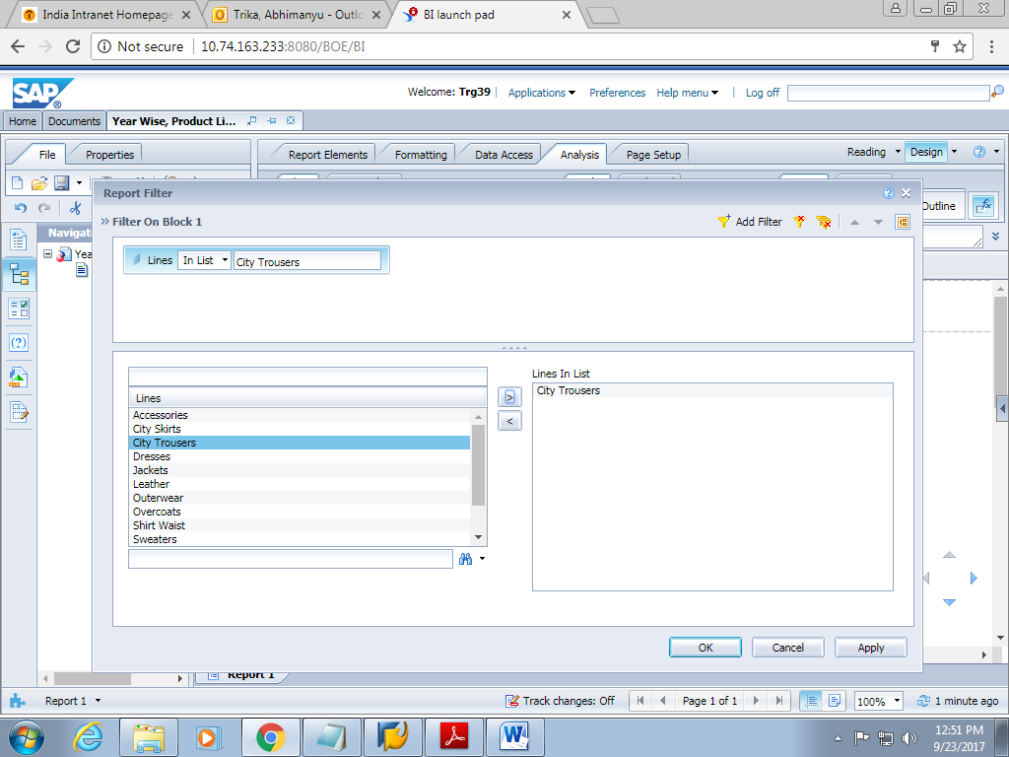

1. The above filter will produce this output.

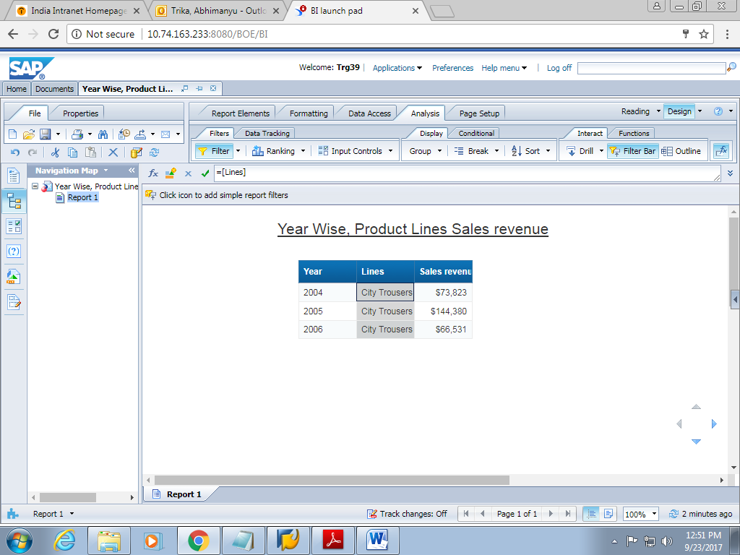

1. Save the document as Year Wise Sales revenue for City Trousers Report.

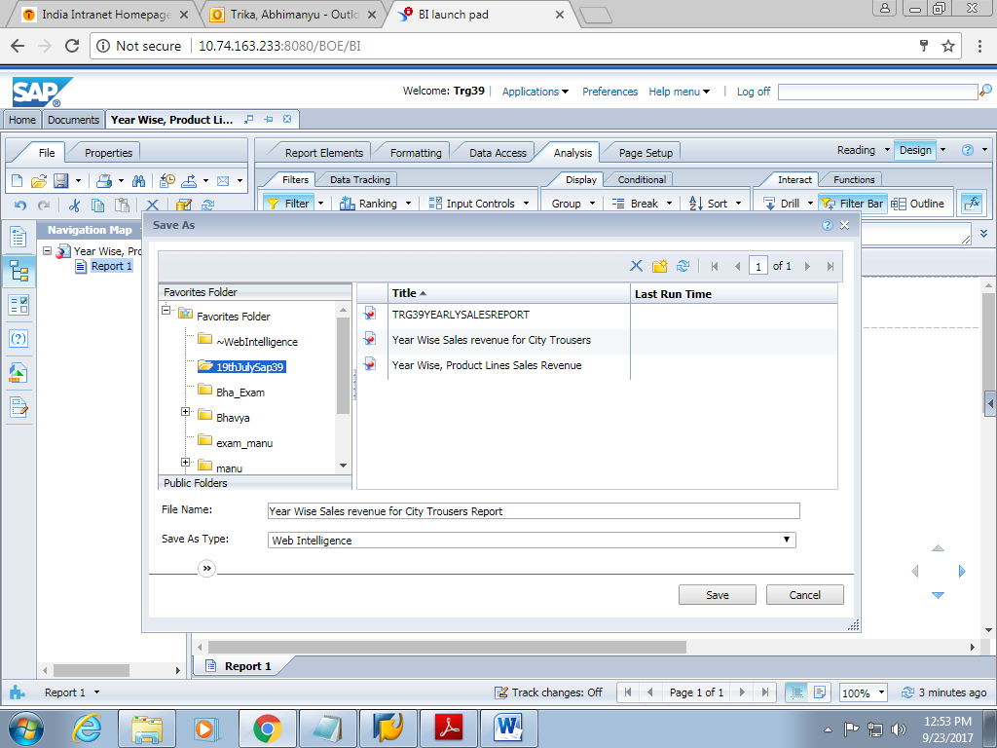

**2.3 : Apply multiple report filters.**

1. Open the Year Wise Sales revenue for City Trousers Report Filter in Modify

mode to view the data.

1. Drag Year into the Query Filter Panel.

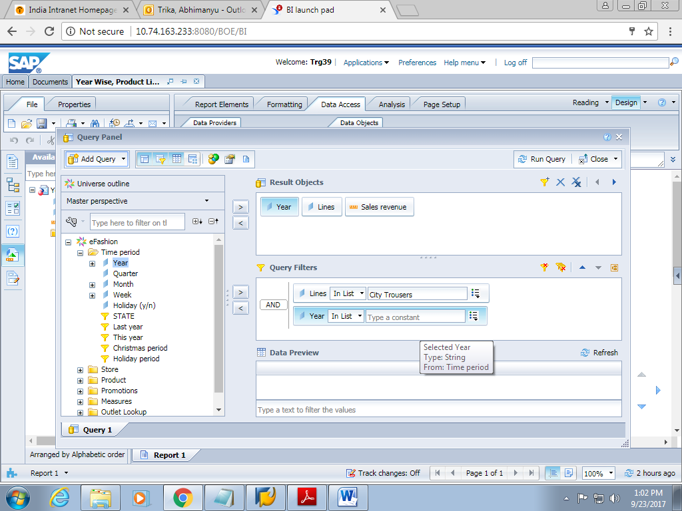

1. From the values in the list, add Year “2004” as a filter and then run the query.

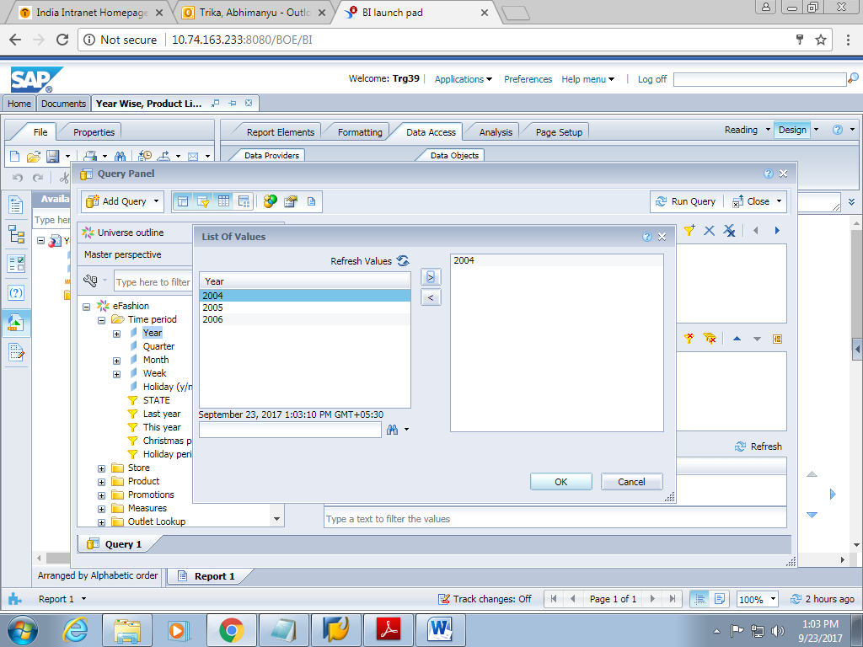

1. The output of the query with multiple filters will look like this.

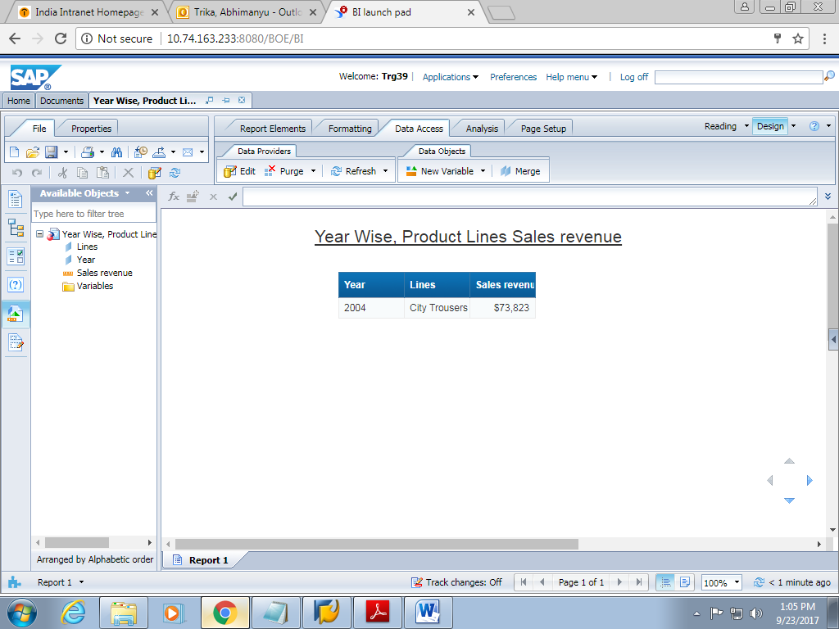

1. Save the document as Year Wise Sales revenue With Multiple Filters.

**3.1 Predefined prompts**

1. Logon to Sap BO using your credentials.



1. Open the Year Wise, Product Lines Sales revenue document in Modify mode.
2. Click Edit Query on the toolbar.
3. Drag the pre-defined Filter object Christmas period from Time period class to

the Query Filters pane of the document.

1. Drag the pre-defined prompt “Prompt for a Line Item?” from the Product class in

Query Filter pane.

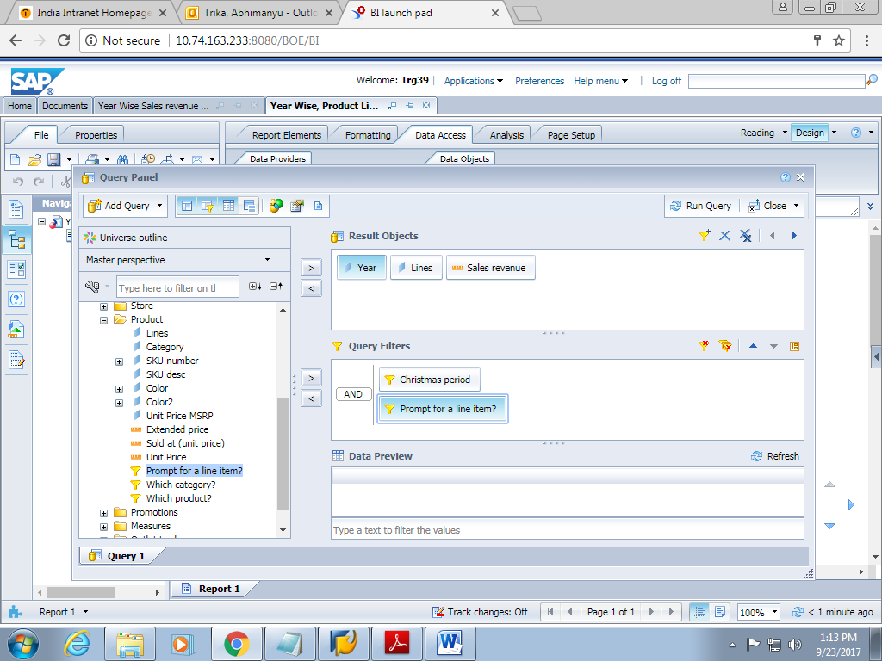

1. In the Prompts dialog box, select City Trousers for Lines. Click the Run Query

button.

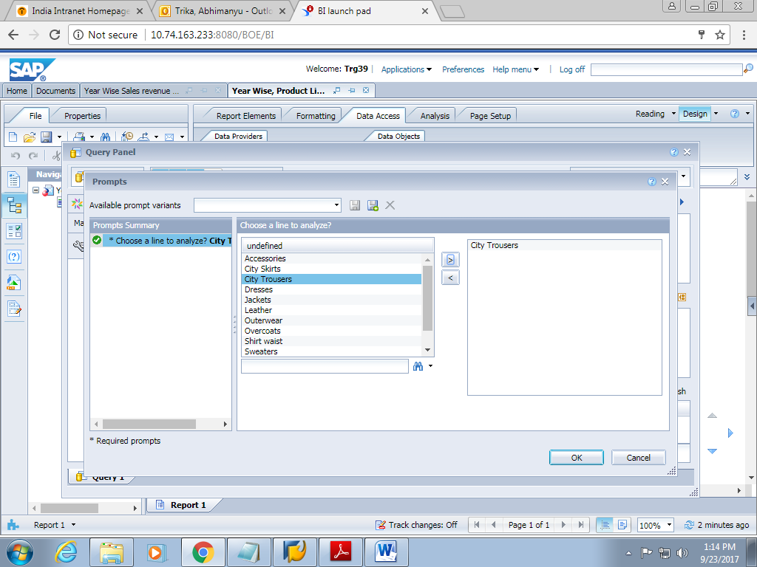

1. The output will be displayed with the Year Wise, Product Lines Sales revenue for selected Lines.

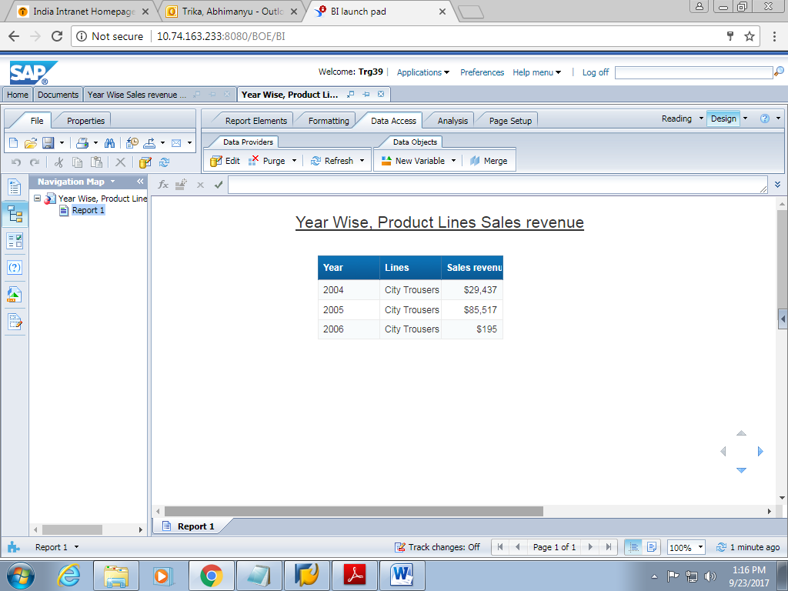

1. Save the document as Year Wise Sales Revenue for Lines

**3.2: User-defined prompts**

1. Open the Year Wise, Product Lines Sales revenue document in Modify mode

to view the data.

1. Drag the pre-defined Filter object Christmas period from Time period class to

the Query Filters pane of the document.

1. Drag the Lines object to the Query Filters pane, click the icon and

select “Prompt” and click Run Query.

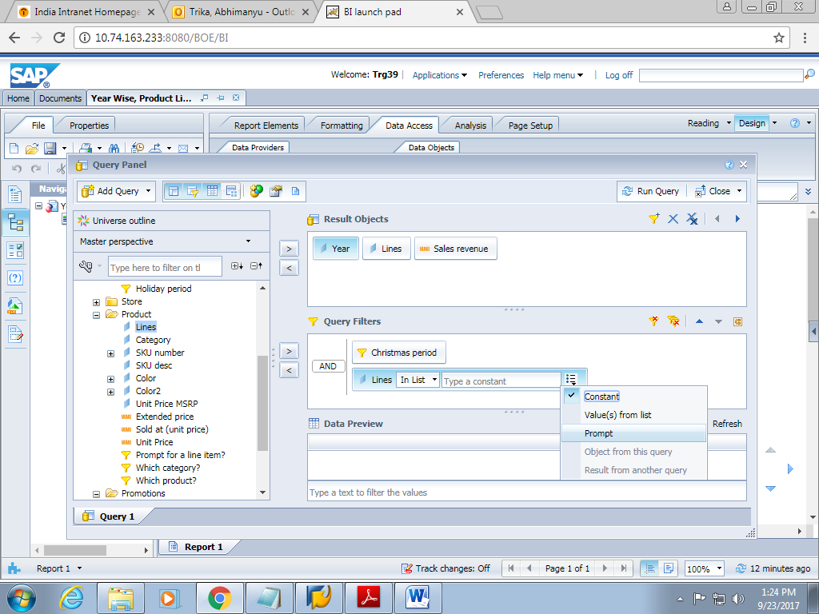

1. In the Prompts window, select Lines as Accessories as shown in the figure

given below.

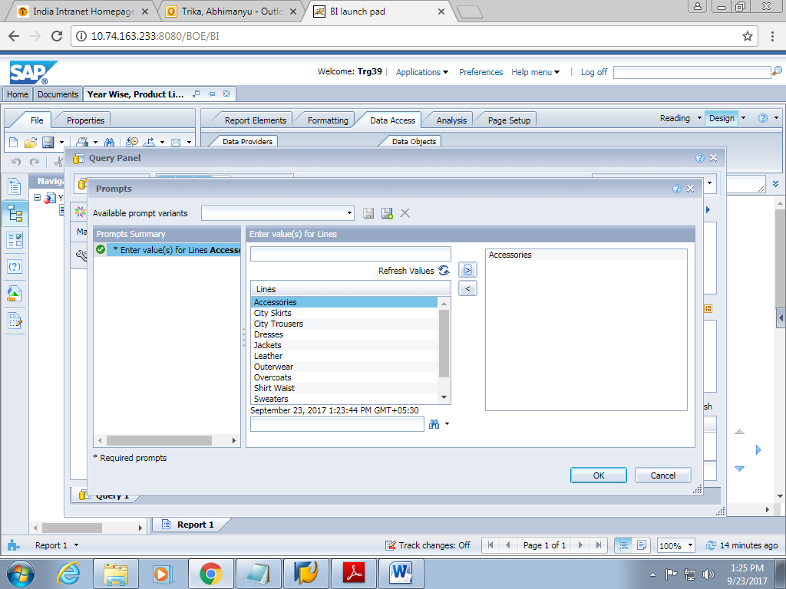

1. The following can be obtained as output.

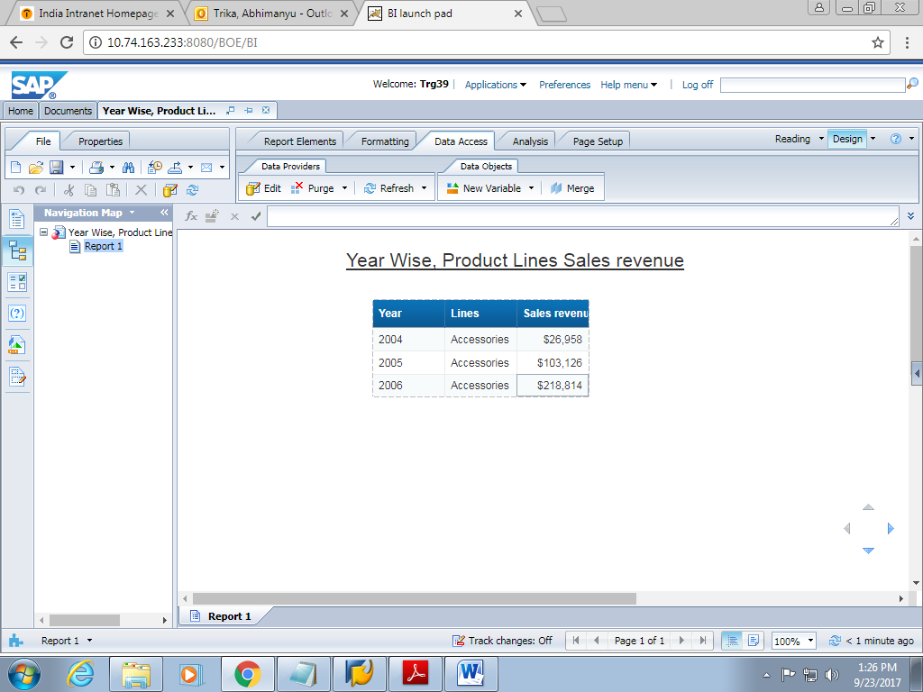

1. Save the document as Year Wise, Product Lines Sales revenue on Selection

and log off by clicking icon.

**4.1: Table templates**

1. Logon to Sap BO using your credentials.
2. Create a new Web Intelligence Document using the eFashion universe from the

list of universes.

1. Selects the objects Year, Quarter and Sales Revenue from the universe.
2. Add the filter Quarter into the Filters.

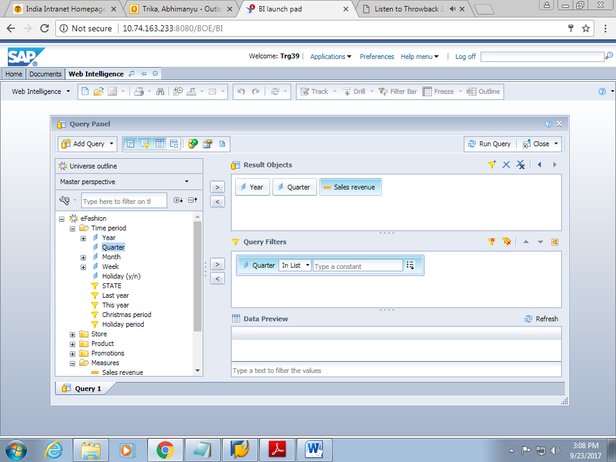

1. Create a prompt based condition on **Quarter**, which will prompt the user to select a **Quarter**. Select **Equal To** ->**Type a new prompt**. Key in the prompt as “**Enter Quarter”**.

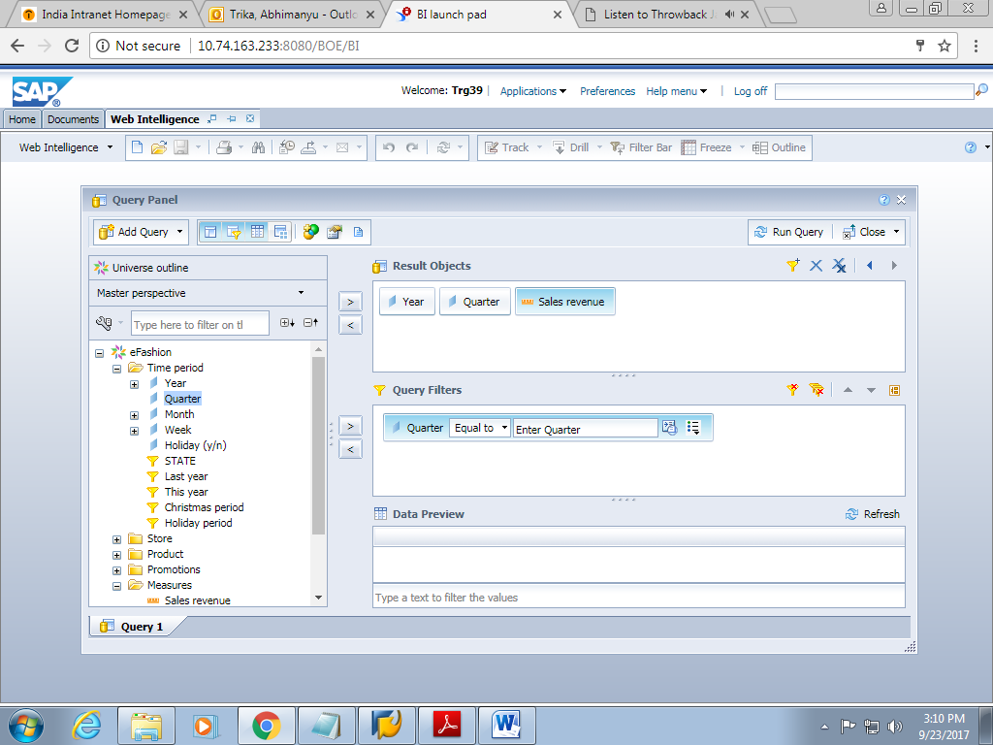

1. Click **Run Query**. Select **Q1** in the prompt as the selected values. View the document.

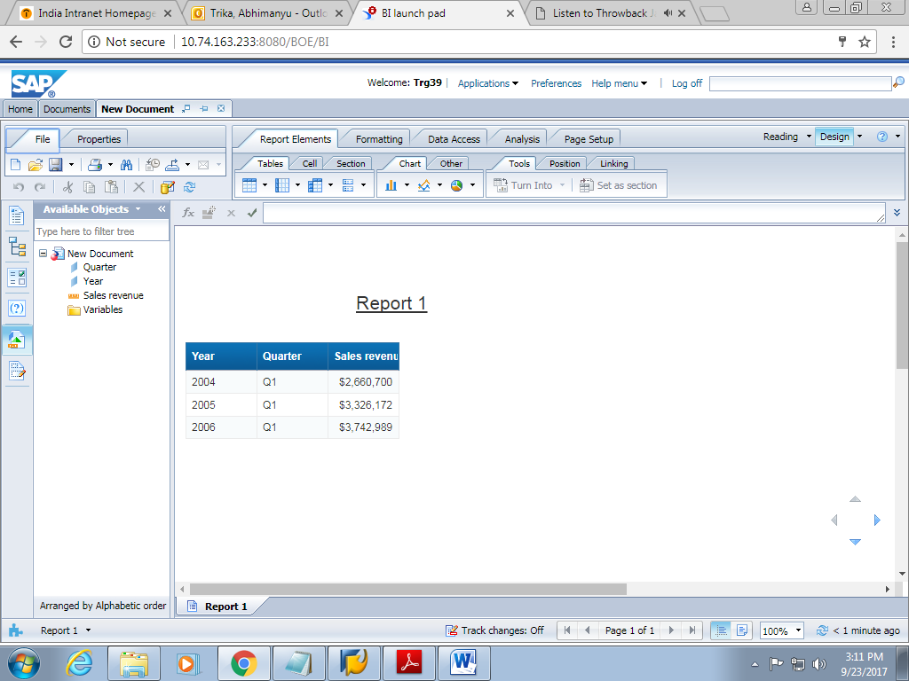

1. The default table template is a vertical table. Remove all the columns from the document, select the table border and drag it to the Datatab.
2. The Report view should be as shown below:

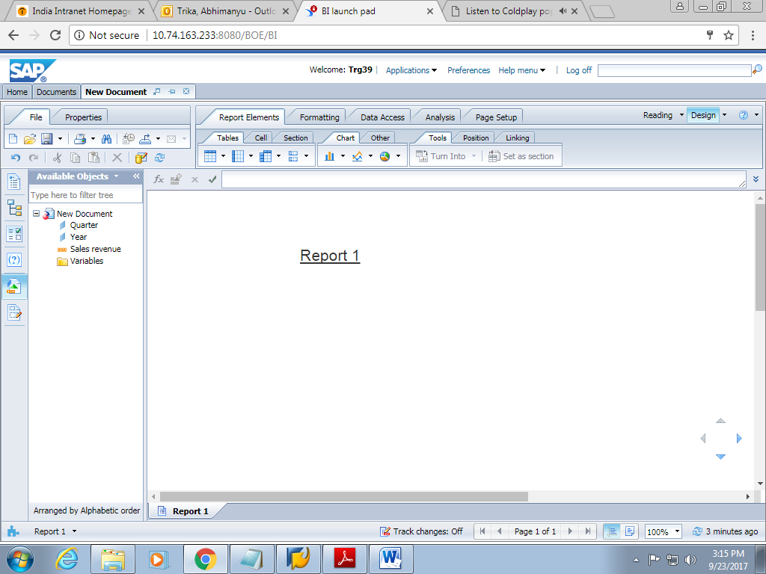

1. Now to enter a horizontal table, right click on the report and click on “Insert” and then on “Horizontal table” and then drag and drop the table anywhere you like.

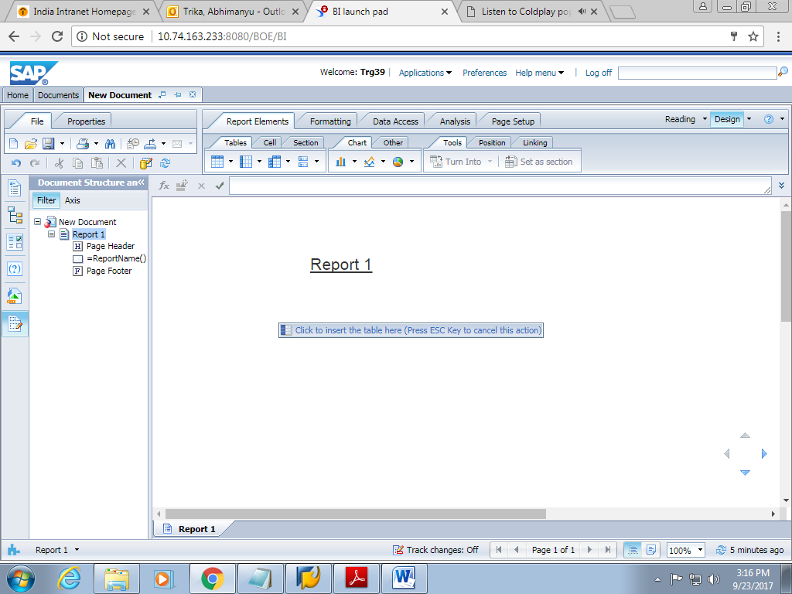

1. Now after dropping the table, it looks like this.

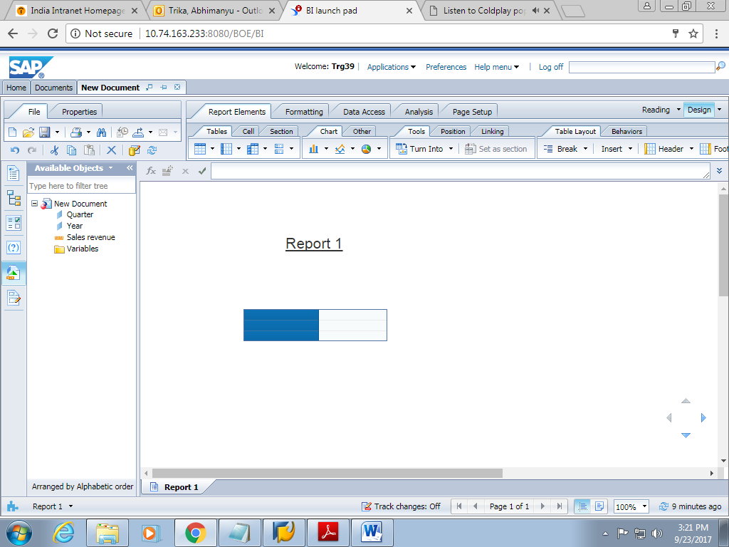

1. Drag and drop the objects from the available objects list to form a filled horizontal table.

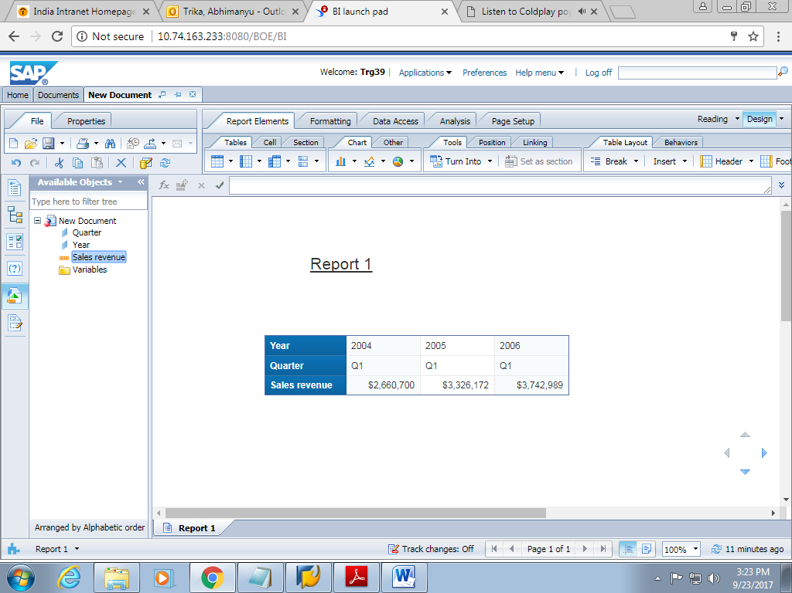

1. In a similar manner, change the table template to CrossTableand view

the document.

1. Save the document as **Different Types of Tables** and log off.

**5.1: Format reports**

1. Logon to the BO using your credentials.
2. Create a new Web Intelligence Document using the eFashion universe from the

list of universes

1. Select the objects Lines, year and sales revenue from the universe and then run the query.

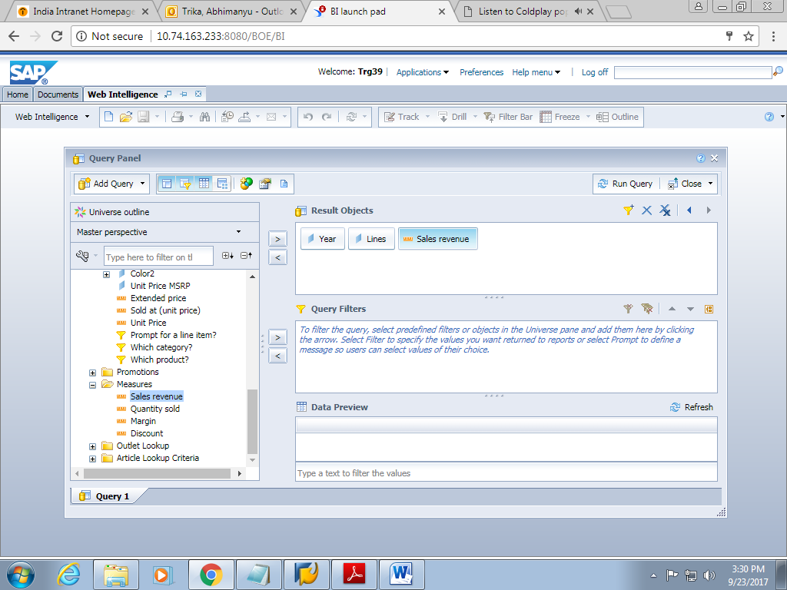

1. Select the lines column and apply the formatting.

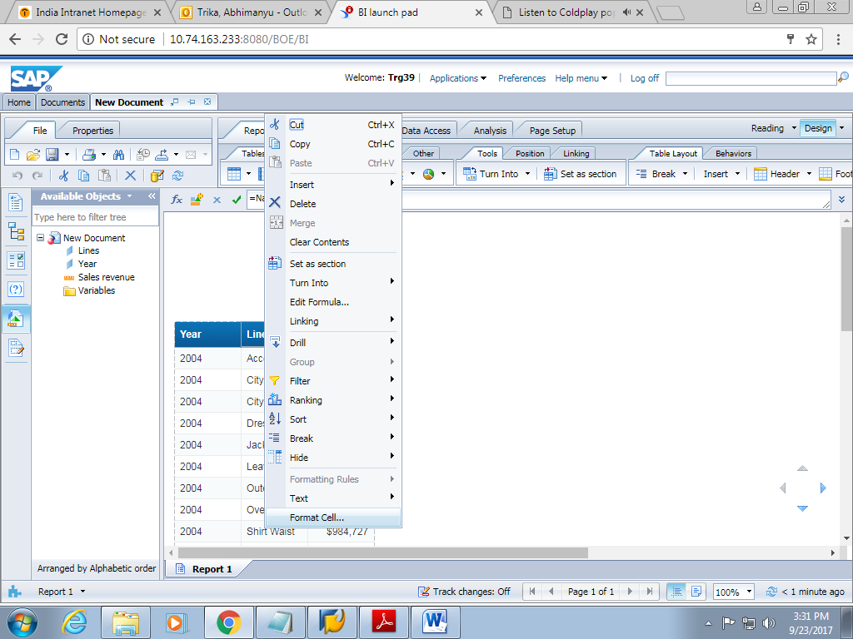

1. After formatting, the report looks like this.

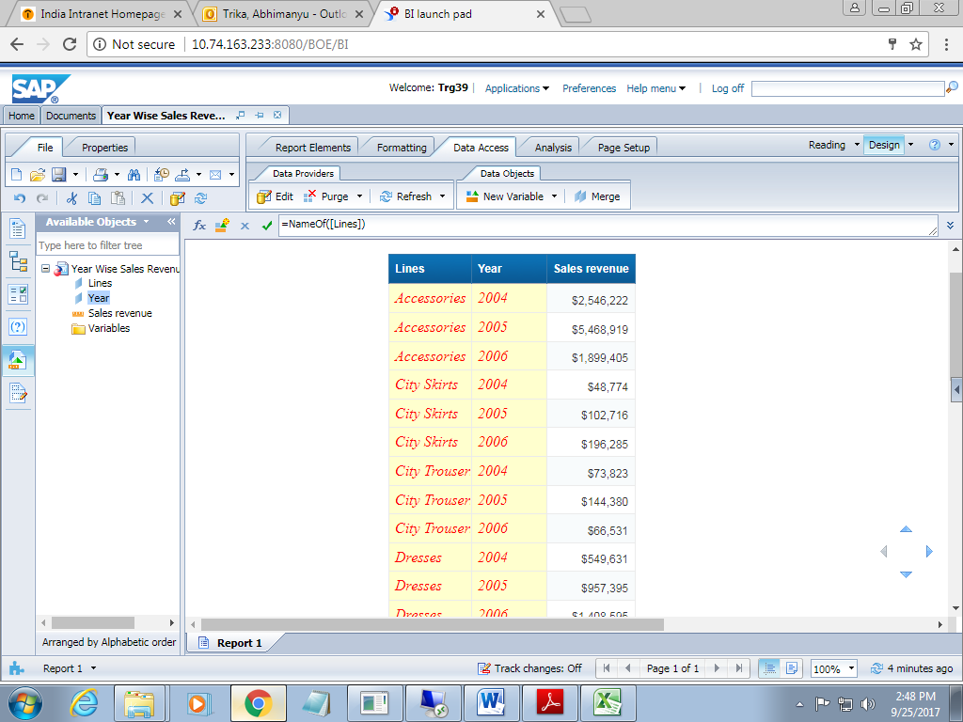

**6.Master –Data report**

In this we will be doing section part and break part

1. Create a new report which should contain the following dimensions

Year

State

Line

Quantity sold

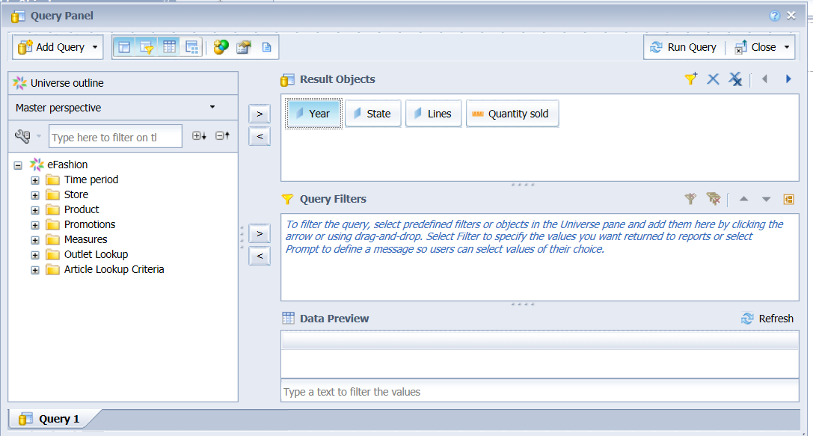

1. Apply filter to year . drop it to the filter panel tab
2. Create a prompt to this filter
3. On clicking on run query, firstly the prompt window will appear

It will ask for entering the value

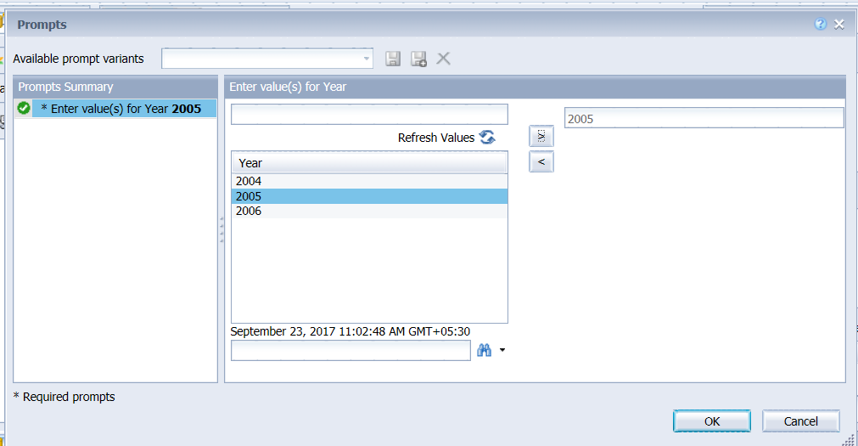

1. On entering value , click on ok

The report will look like as

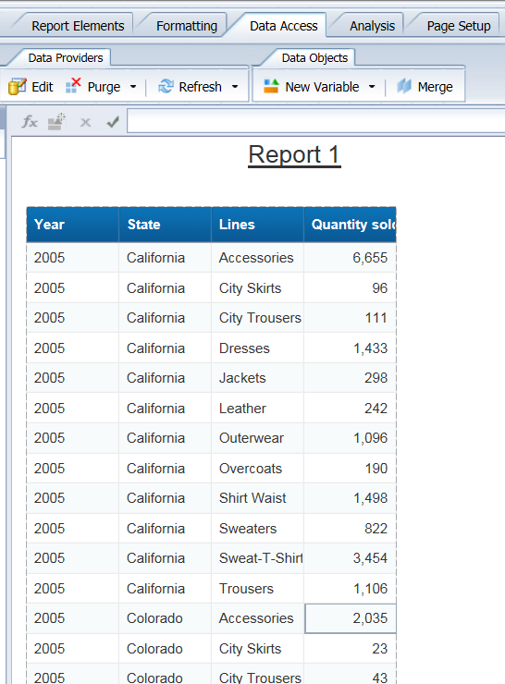

Now creating a section to a column

1. Select state column
2. On right clicking, select set as selection

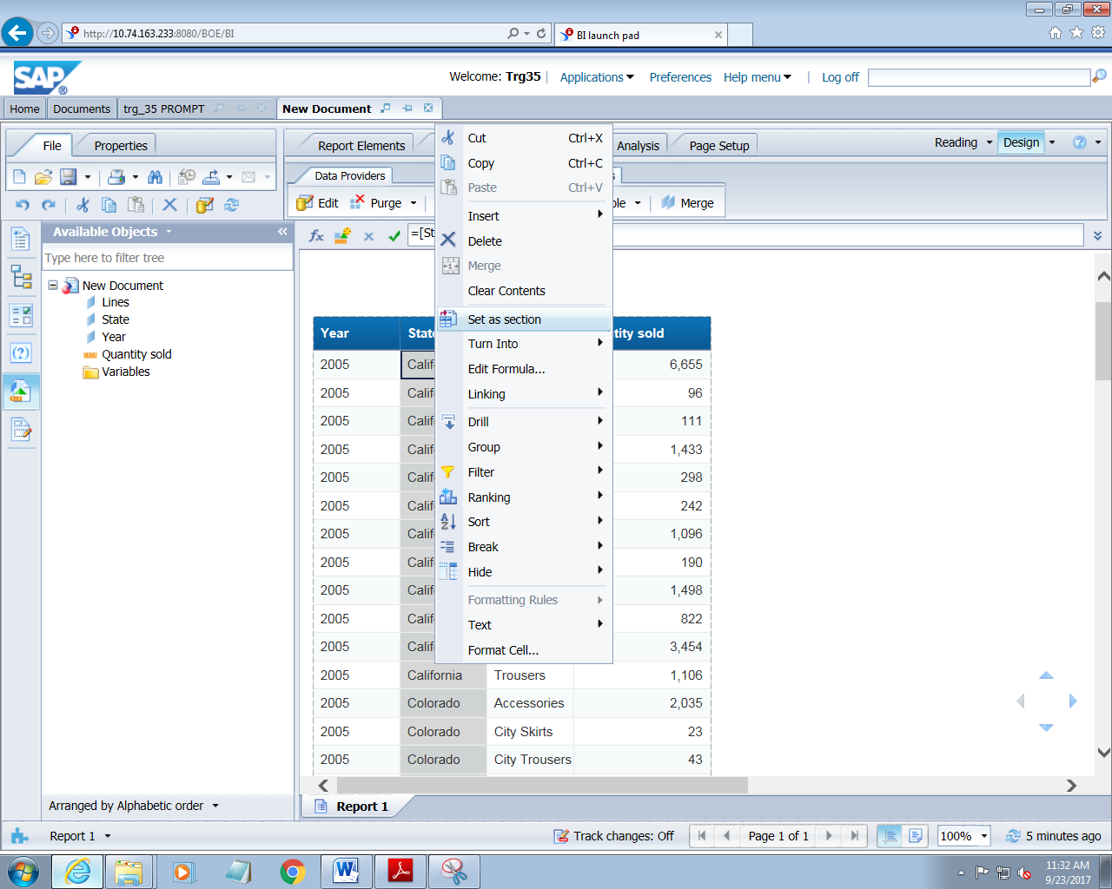

1. Now on applying section , the report will look like as

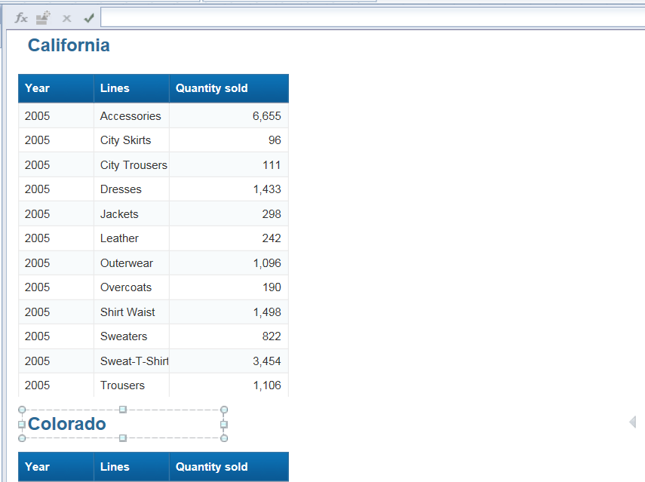

**7.BREAKS**

1. Create a new report which should contain the following dimensions

Year

Line

Category

Sales revenue

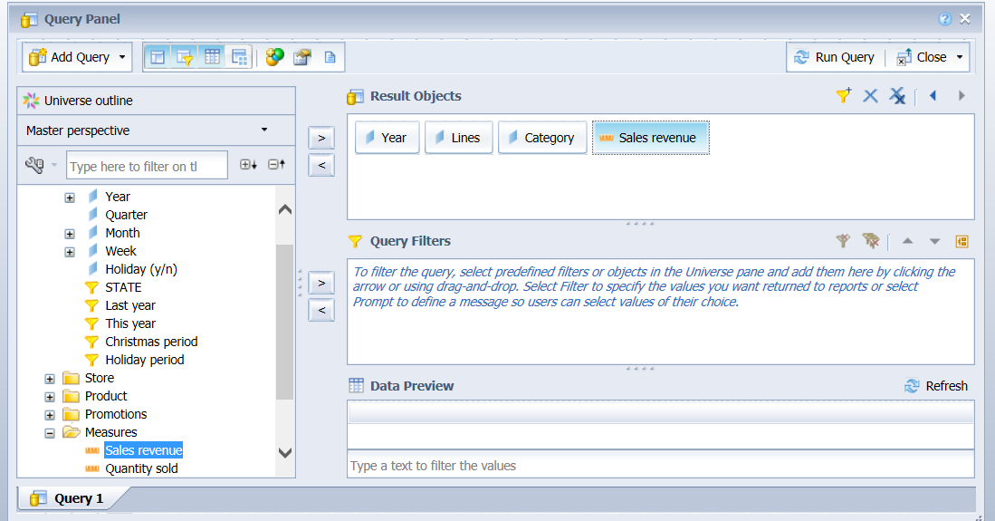

1. Drag and drop line to the filter panel
2. Apply prompt condition on to this

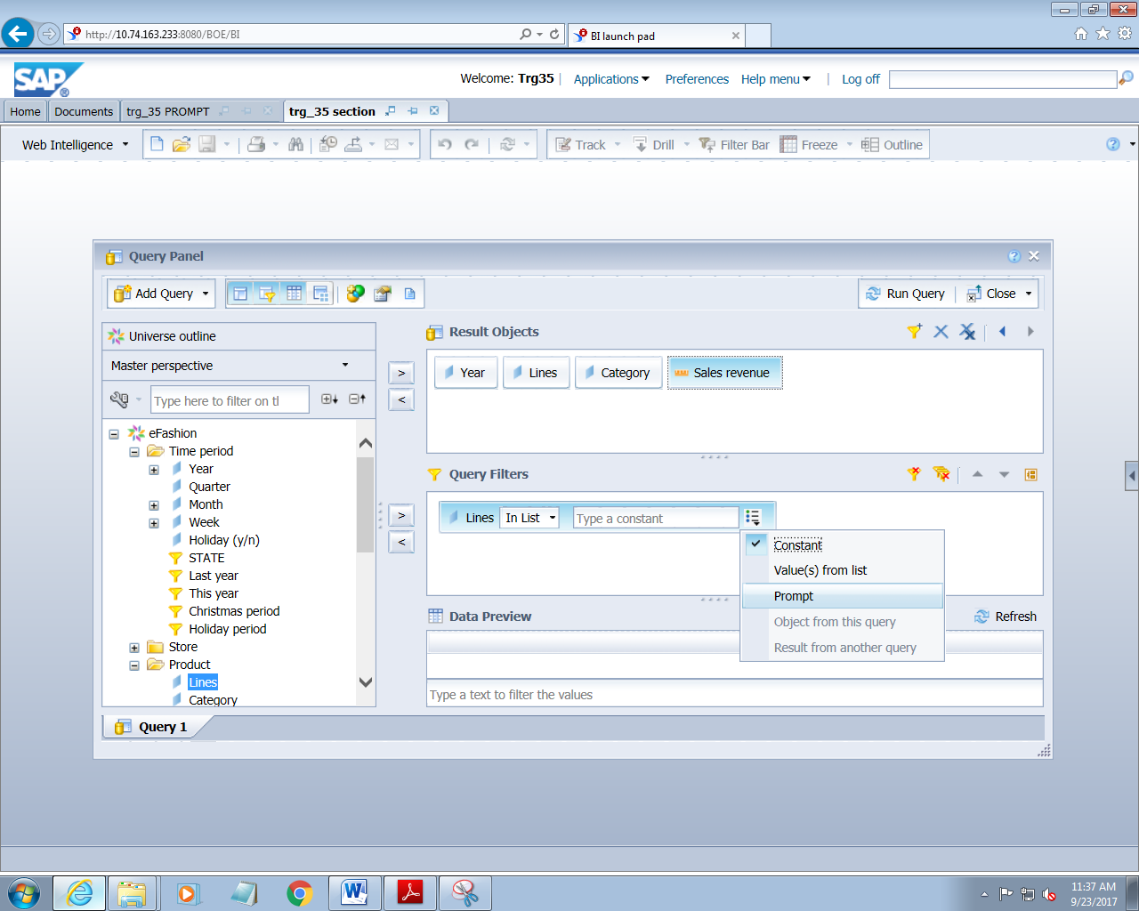

1. On clicking on run query, it will ask for entering the value as

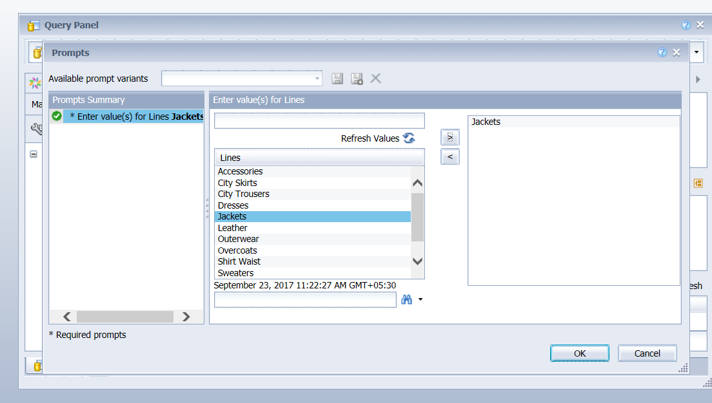

1. On entering value, the report will be as

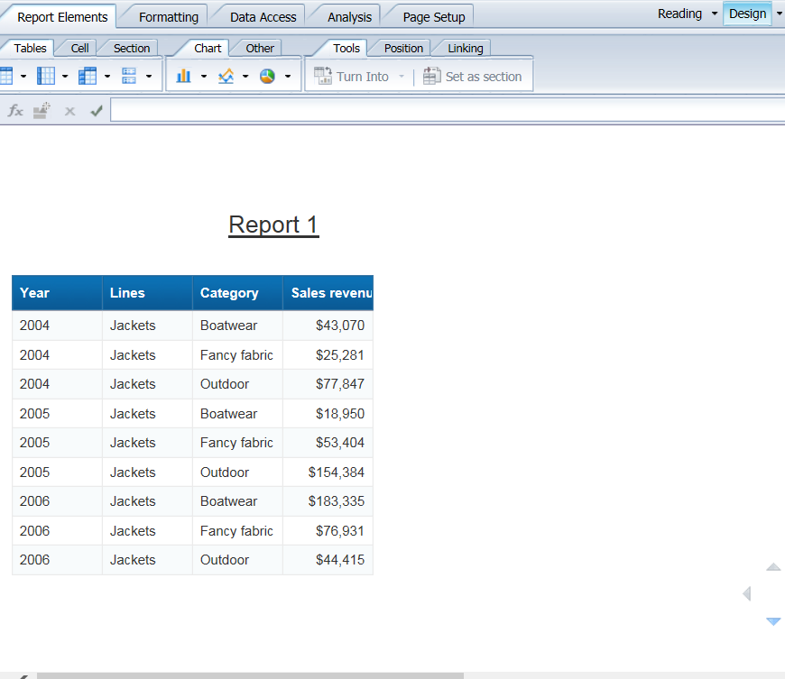

1. Right Click on lines column and add break as

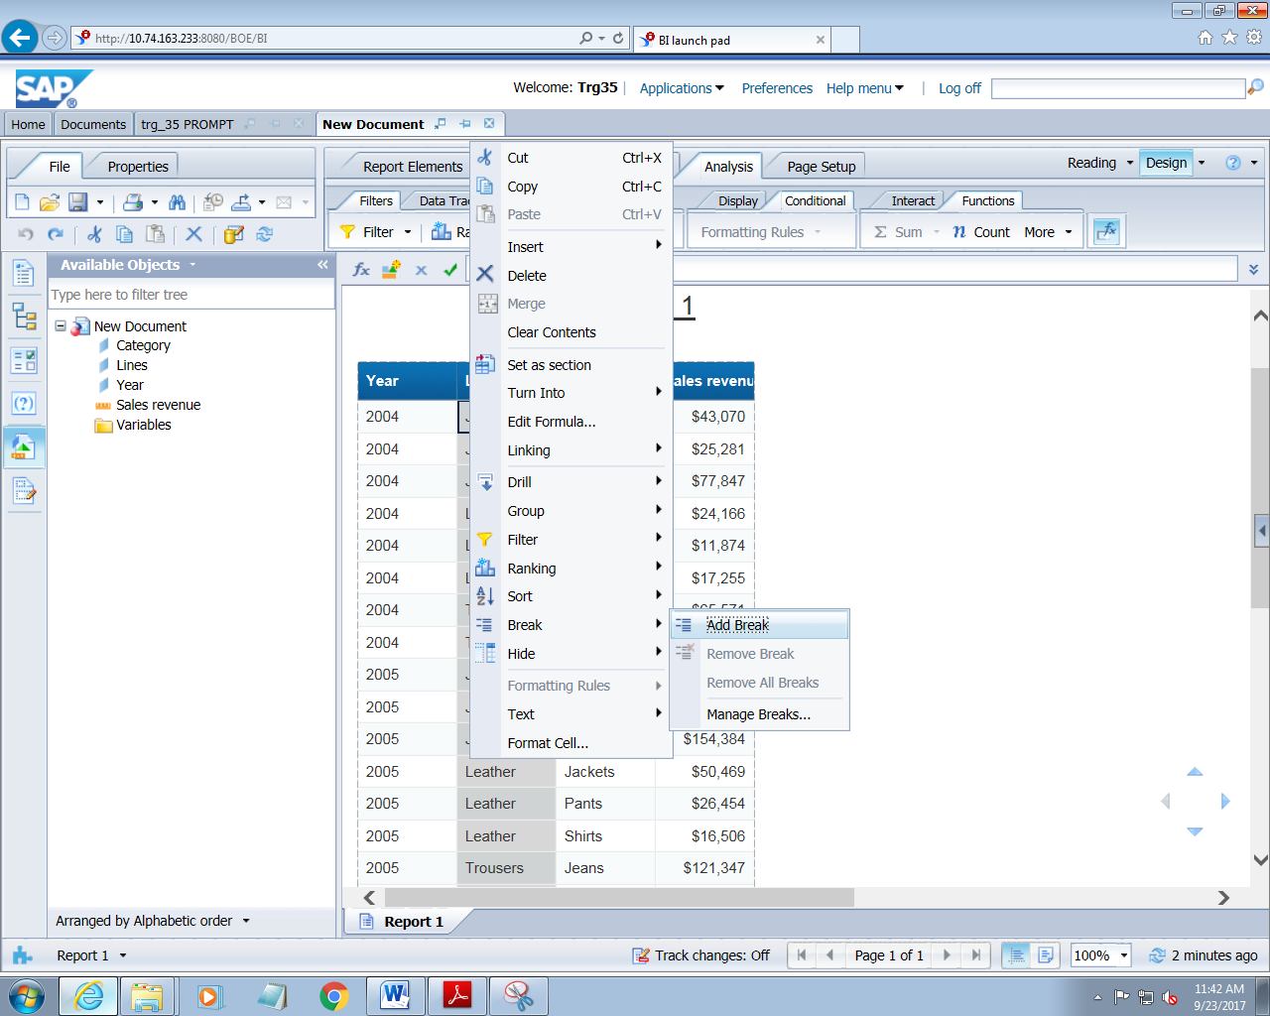

1. On clicking on add break

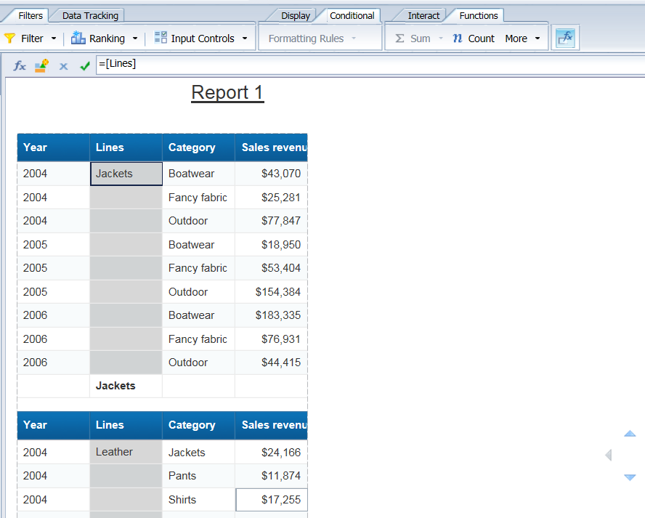

1. We can set total sum of sales revenue for each accessories
2. Go to Analysis->functions->sum

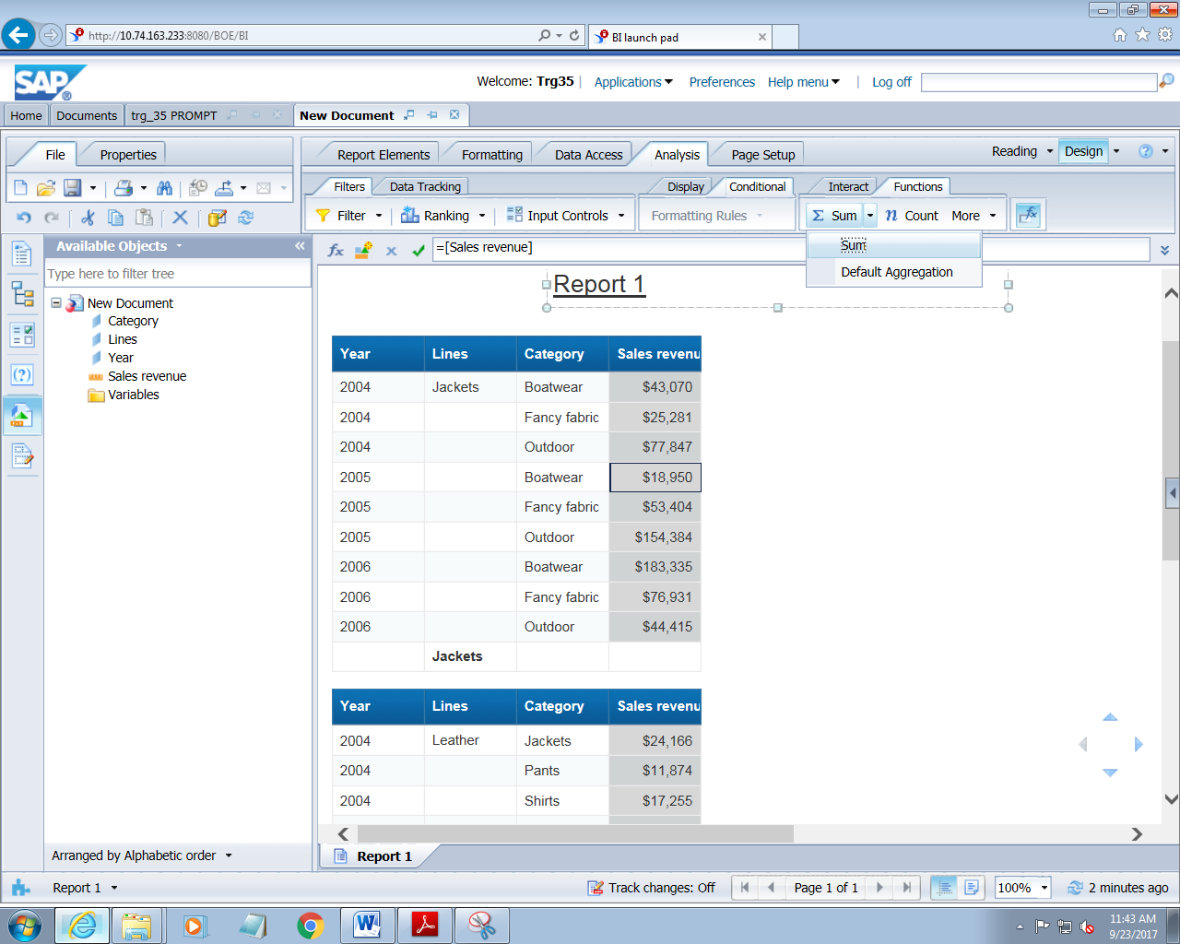

1. On applying all these, the report will be as

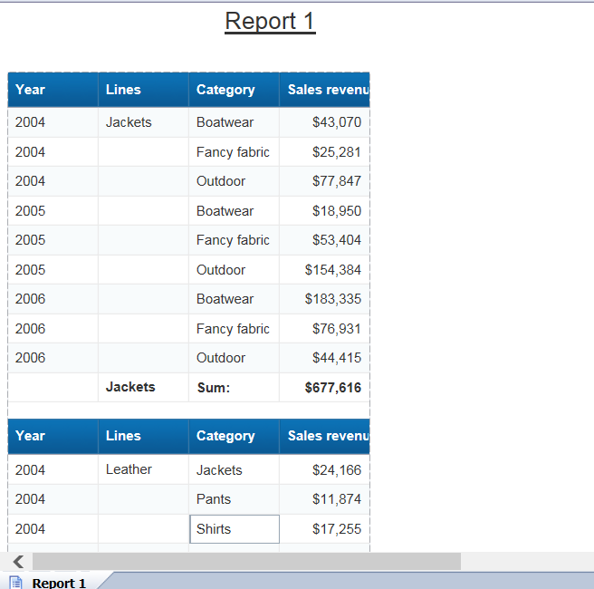

**7.CROSSTAB REPORTS**

1. Create a new report which should contain the following dimensions

Year

Quarter

Line

Category

Sales revenue

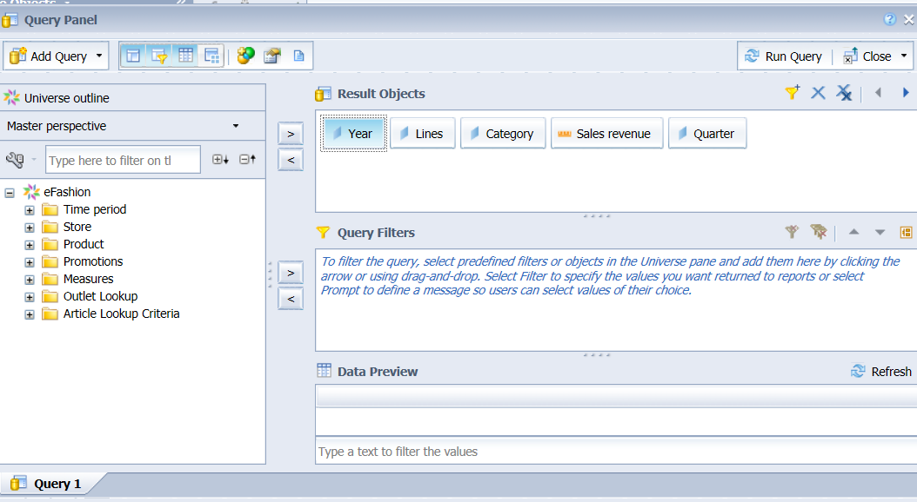

1. Click on run query to see the report

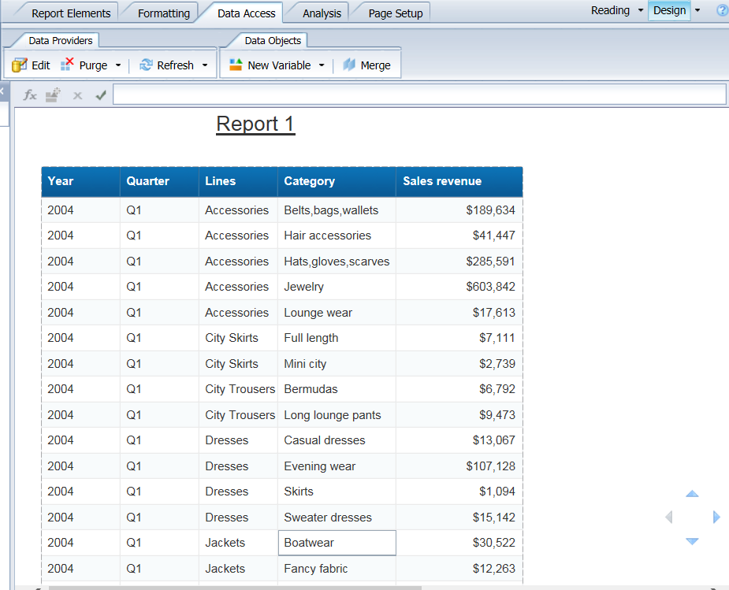

1. Right click on year and select turn into->cross tables

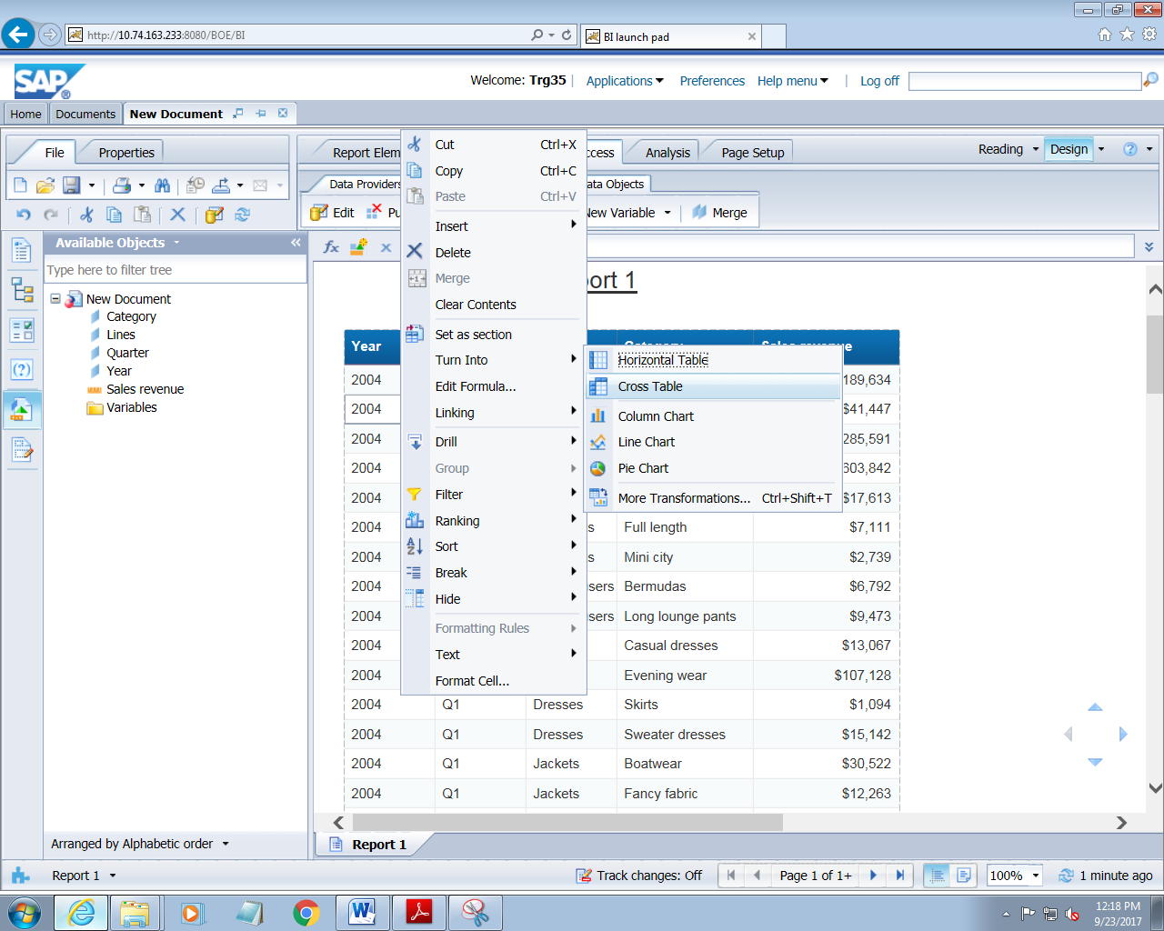

1. The report will be

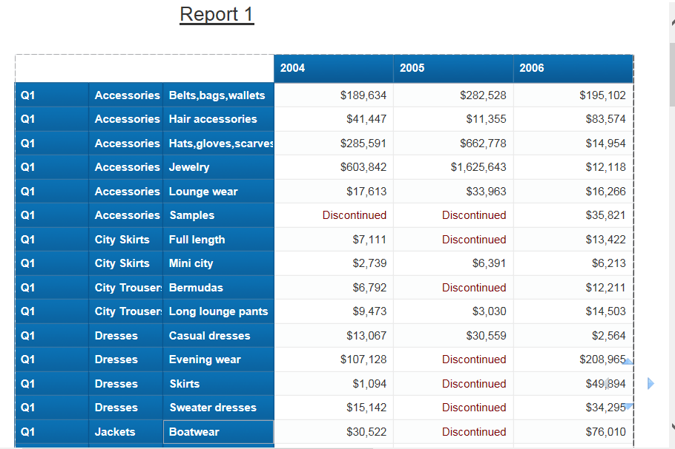

**9.CHARTS**

1. Create a new report which should contain the following dimensions

Year

Quarter

Line

Category

Sales revenue

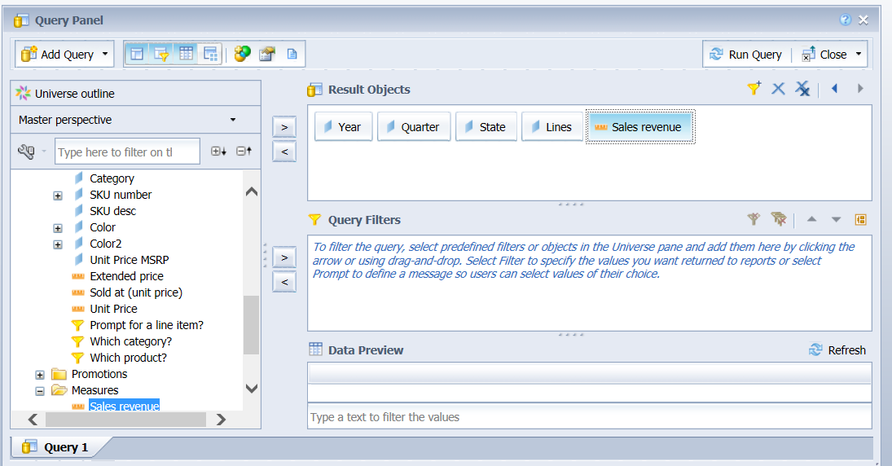

1. Create a condition on year and sales and give it a prompt

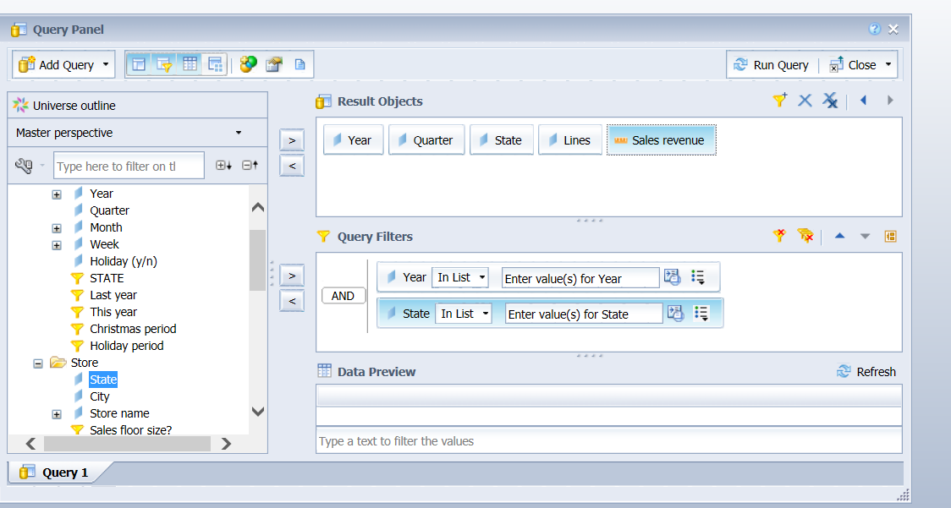

1. On clicking on run query, it will ask for entering the value

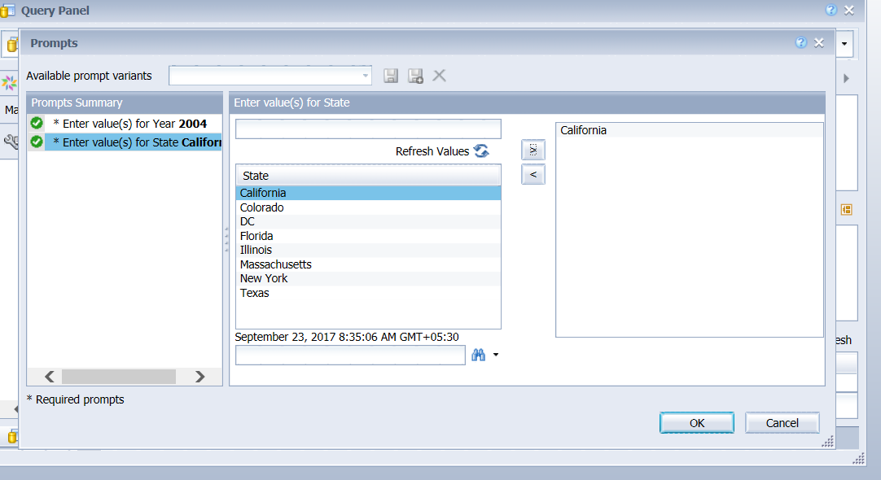

1. Click on run query to see the report

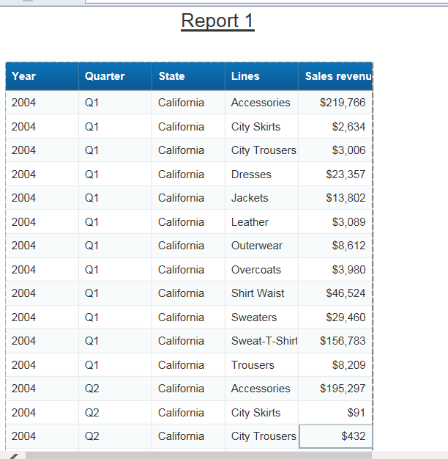

1. Now select the state and set it section

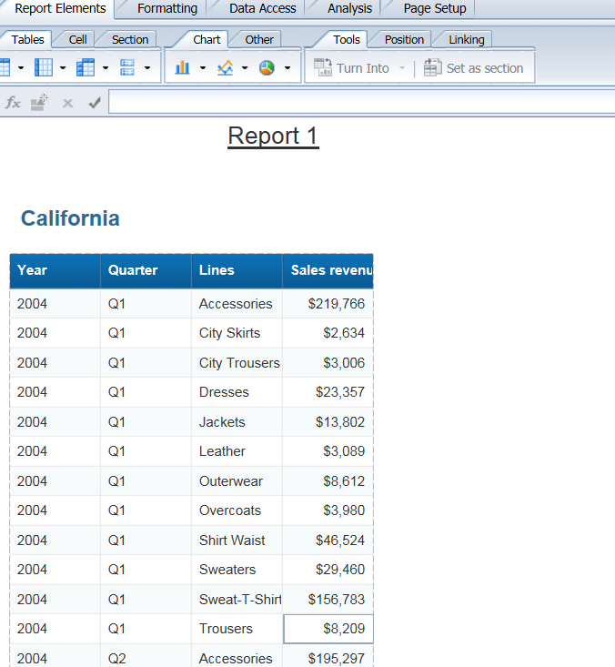

1. Now go to reporting element and click on chart option

There are different charts available like pie chart,line and column chart

Click on any chart option. Drag and drop object to the field

See the report now

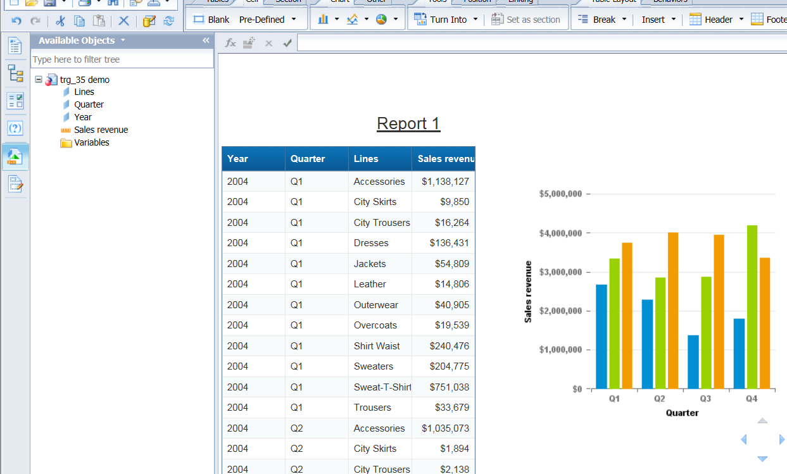

**CREATING CHARTS USING TURN INTO OPTION**

1. Create a new report which should contain the following dimensions

Year

Line

Sales revenue

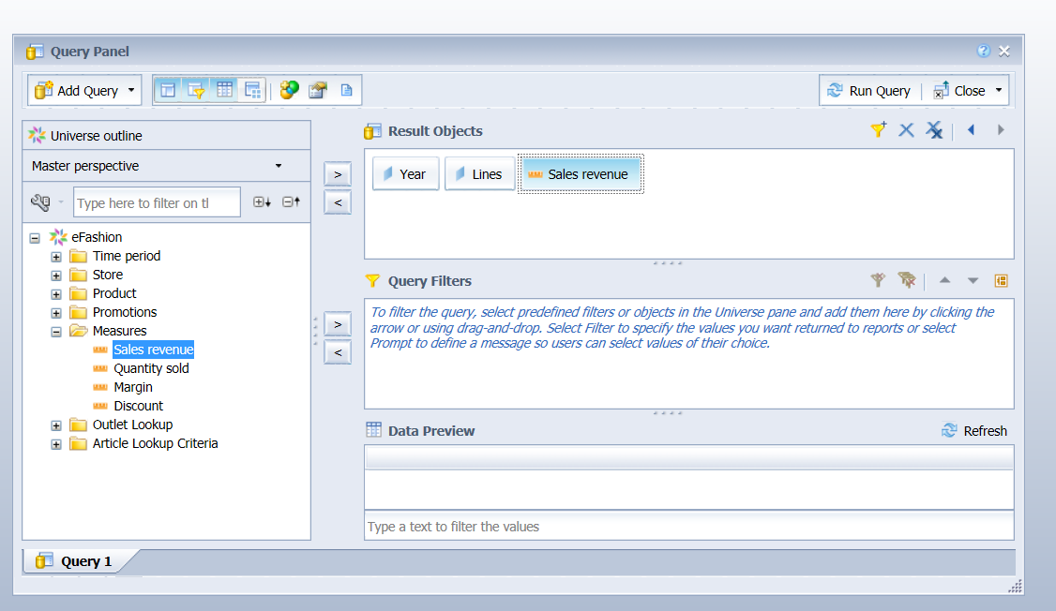

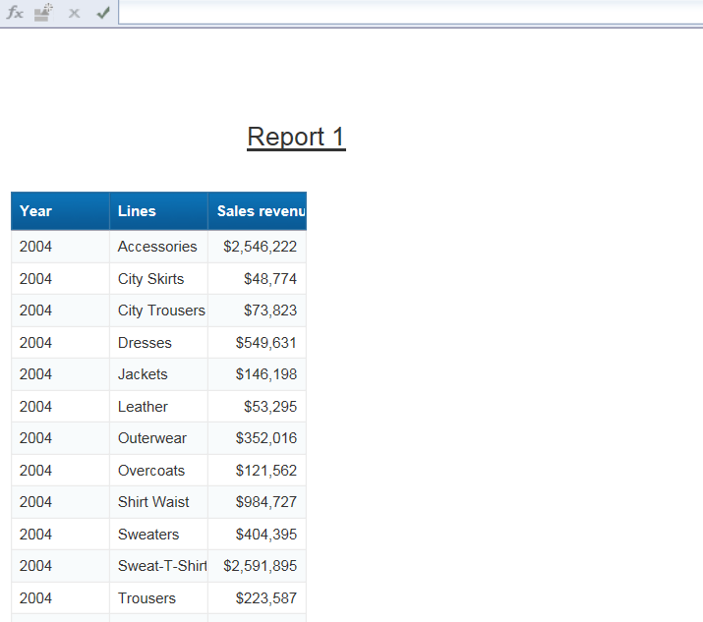

1. Select the year column and set as section

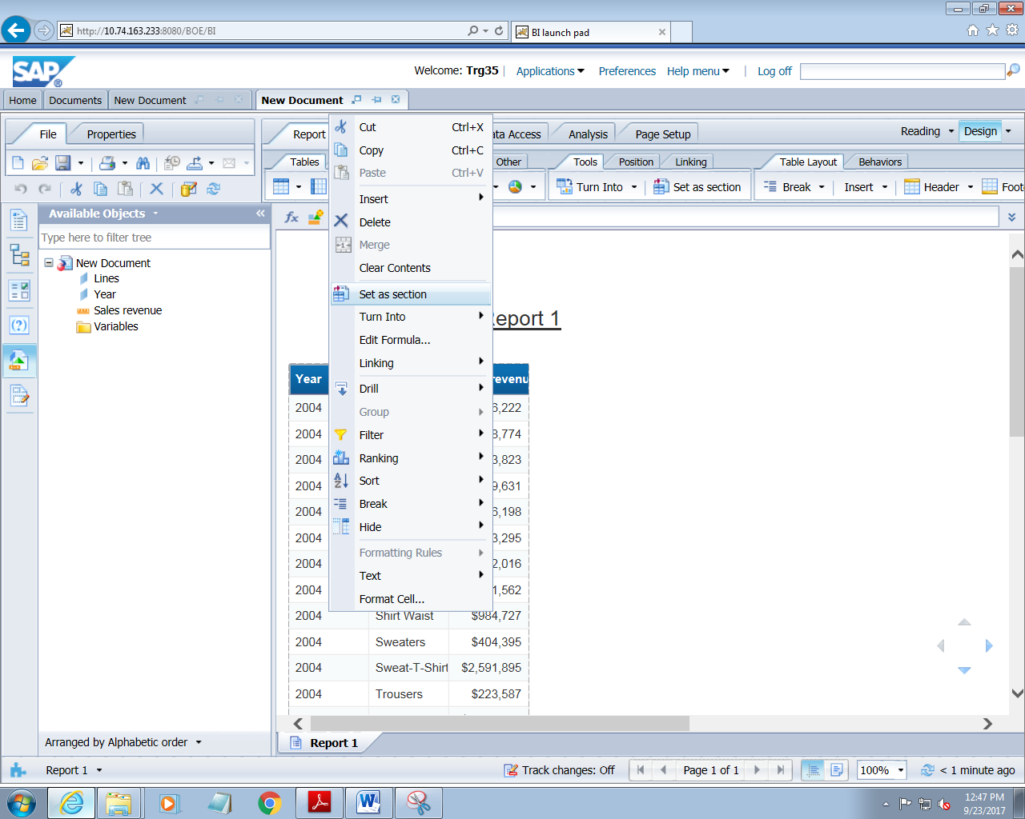

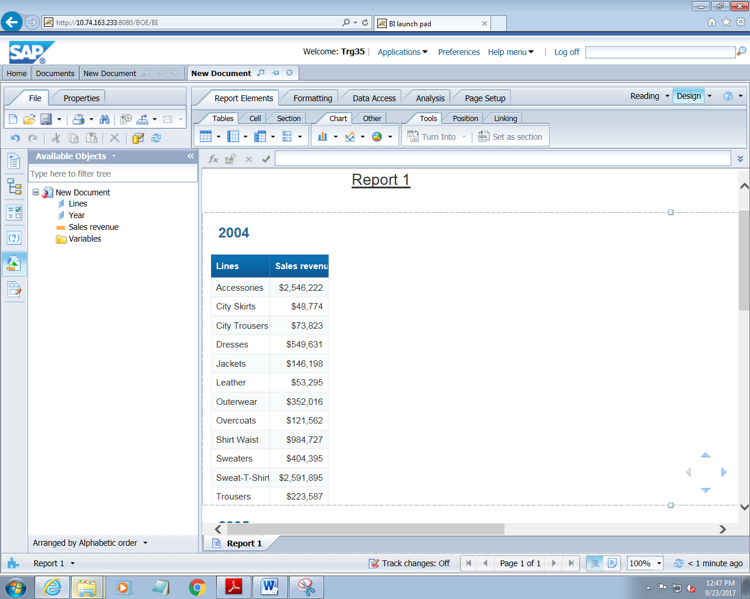

1. Now right click on the table and select turn into option
2. Click the chart box icon option

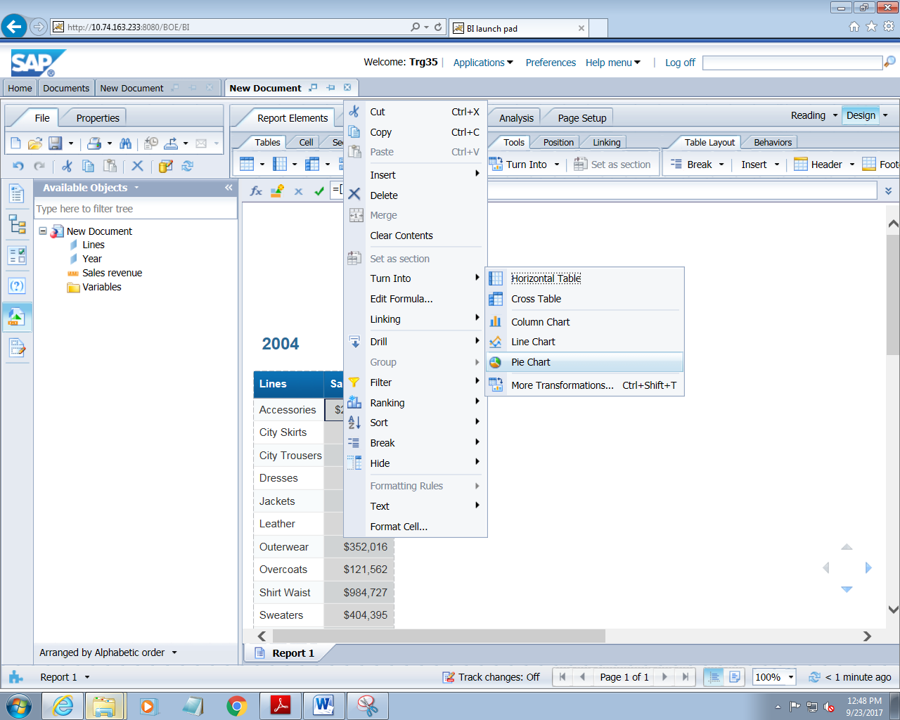

1. Click on pie char and see the report

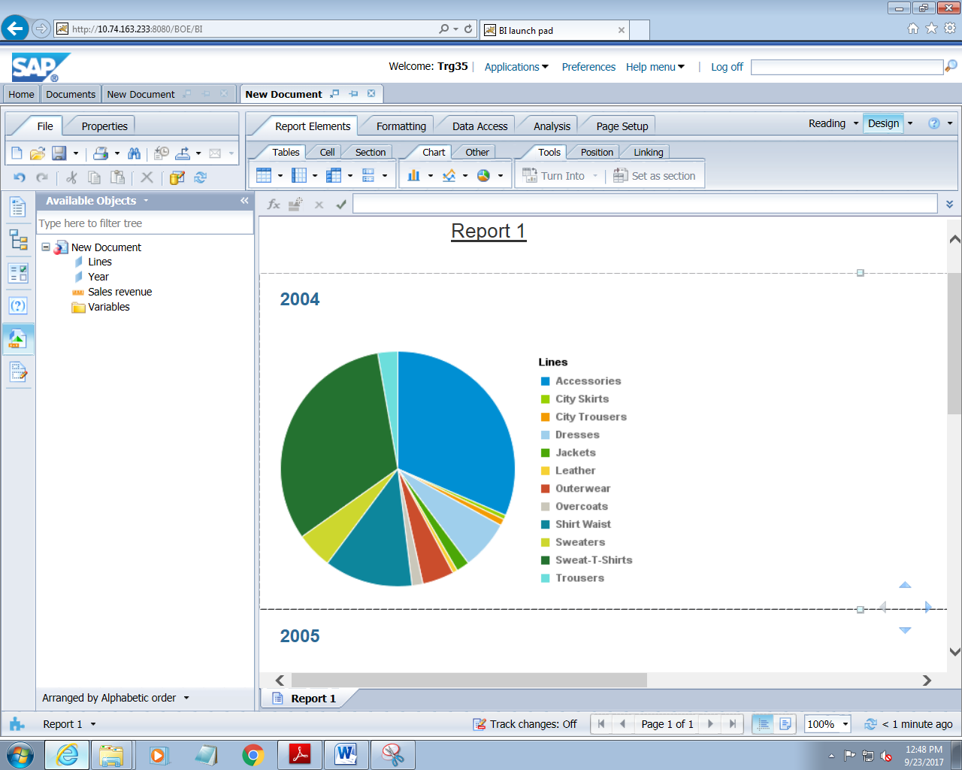

**11.FUNCTION AND FORMULAS**

**11.1 CREATING VARIABLE**

1. Create a new report with the following dimension

Year

Quarter

State

Lines

Sales revenue

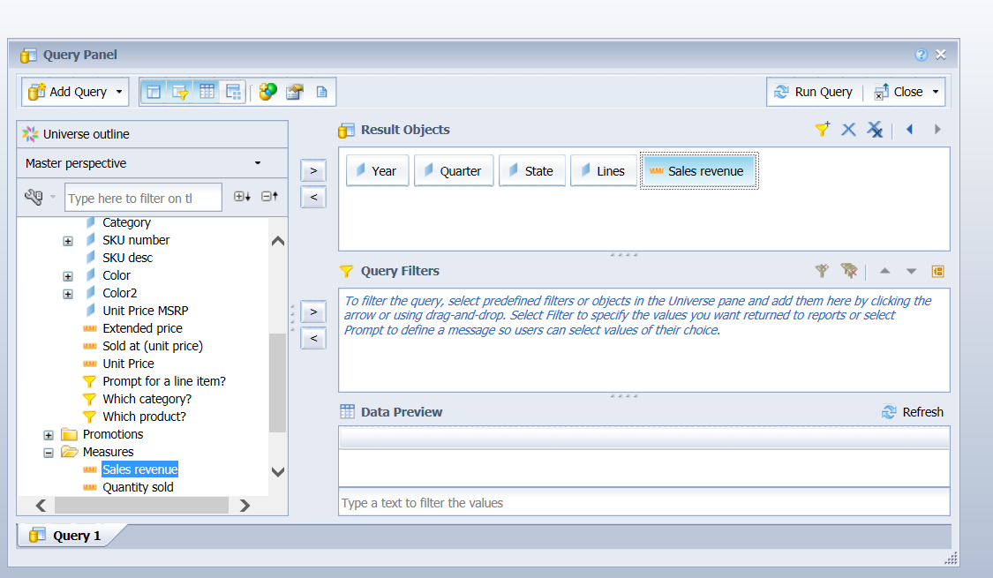

1. Add two filter

Year and sales and select the prompt option to get the value

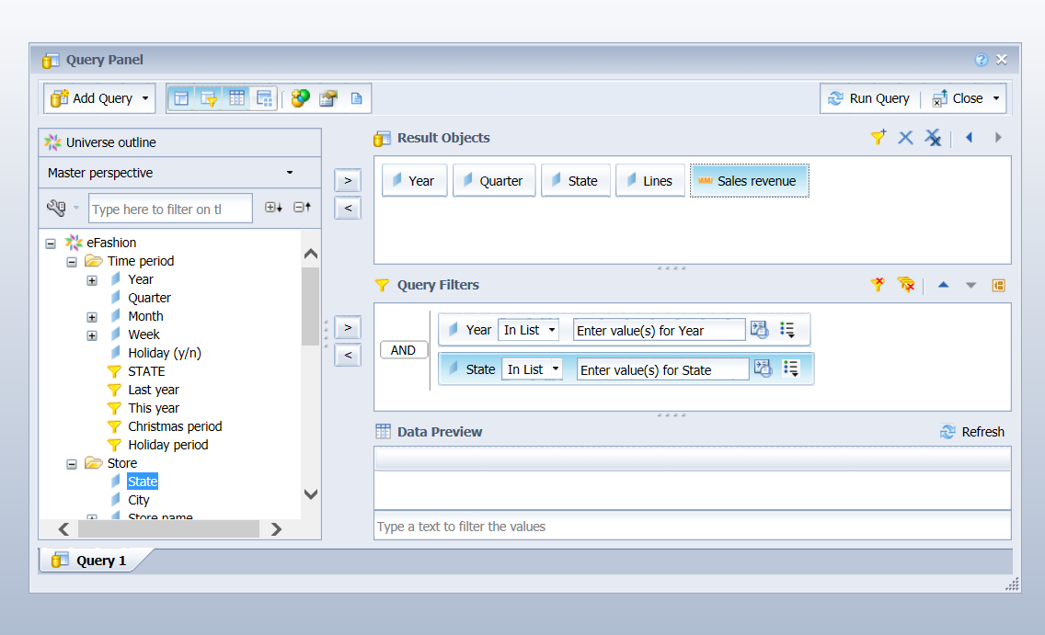

1. On clicking on run query, following window will appear for entering the value for year and state

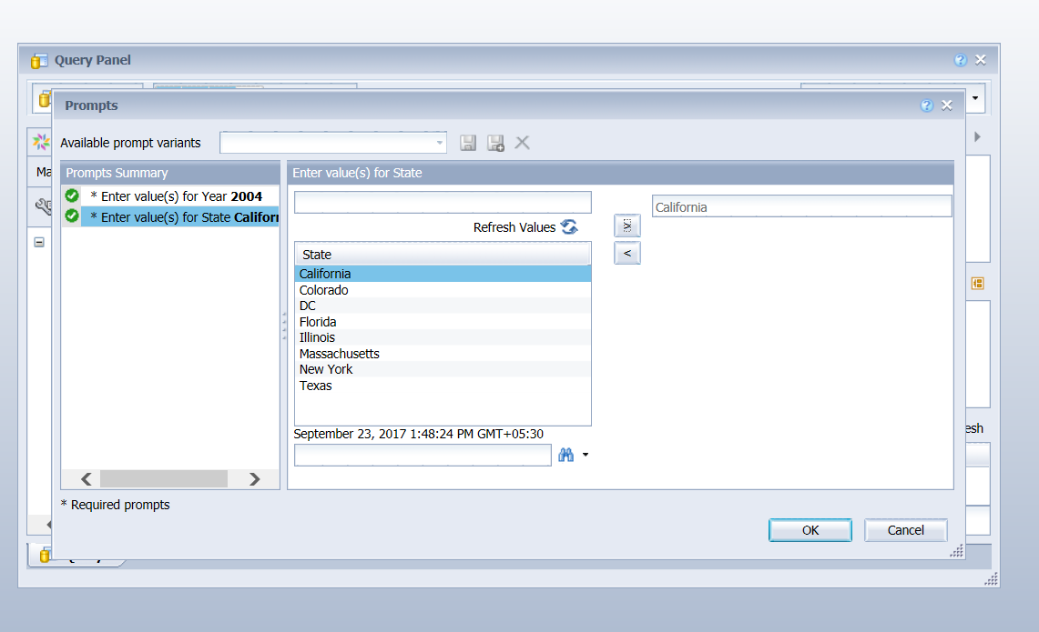

1. The report will look as

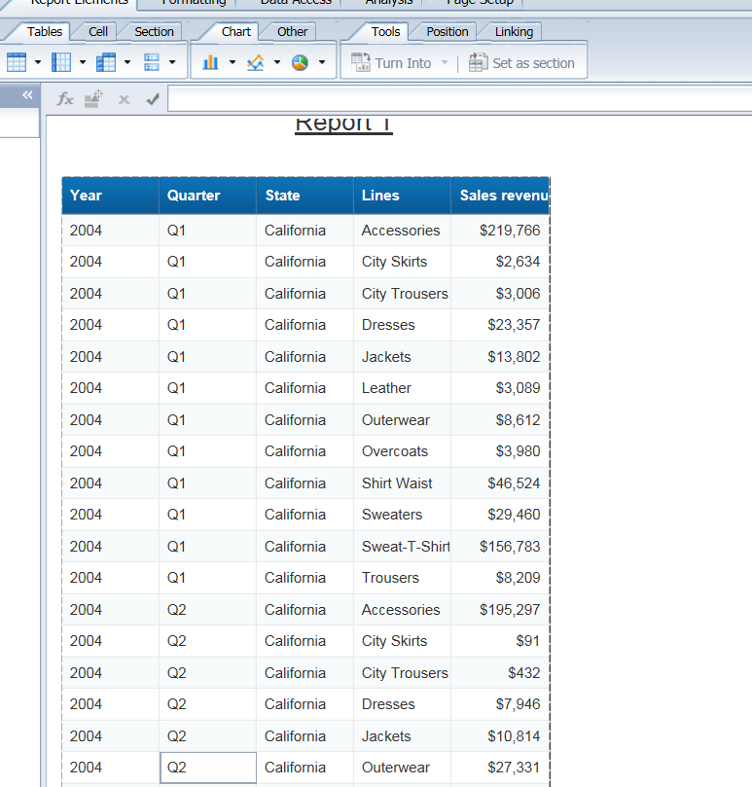

1. Now click on variable tab to create a variable

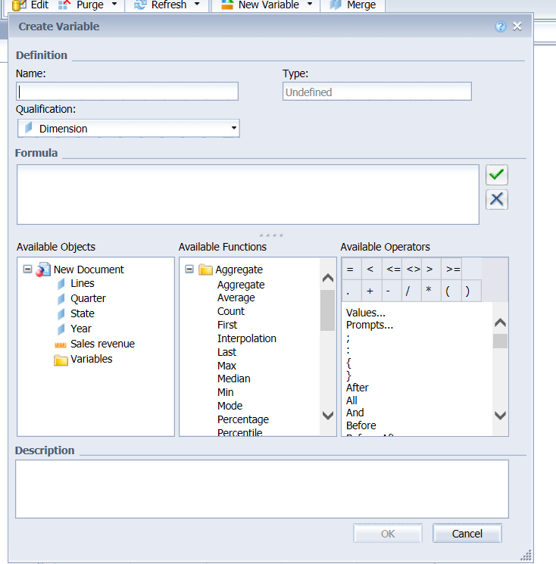

1. In variable pane give variable name a s:maximum sales revenue”

In qualification select “measure”

Create the variable by writing the formula as

Max(sales revenue)

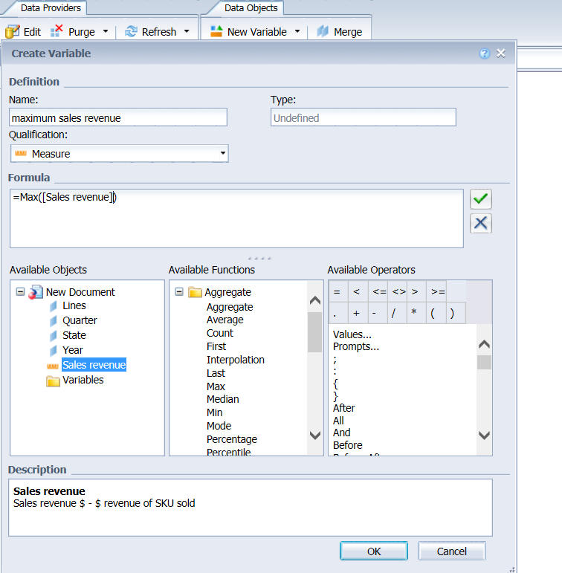

1. Drag blank cell on to the report

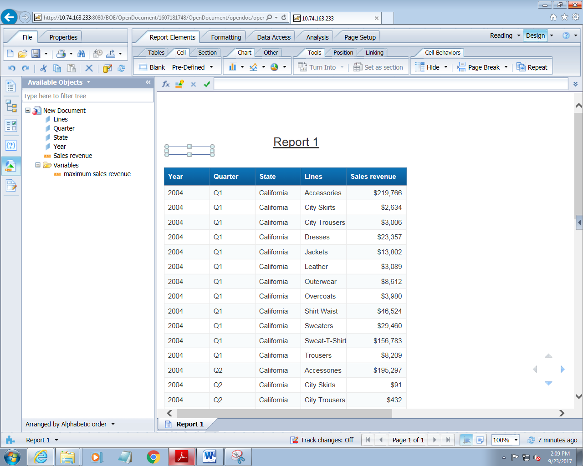

1. Drag the variable “maximum sales revenue” to the cell

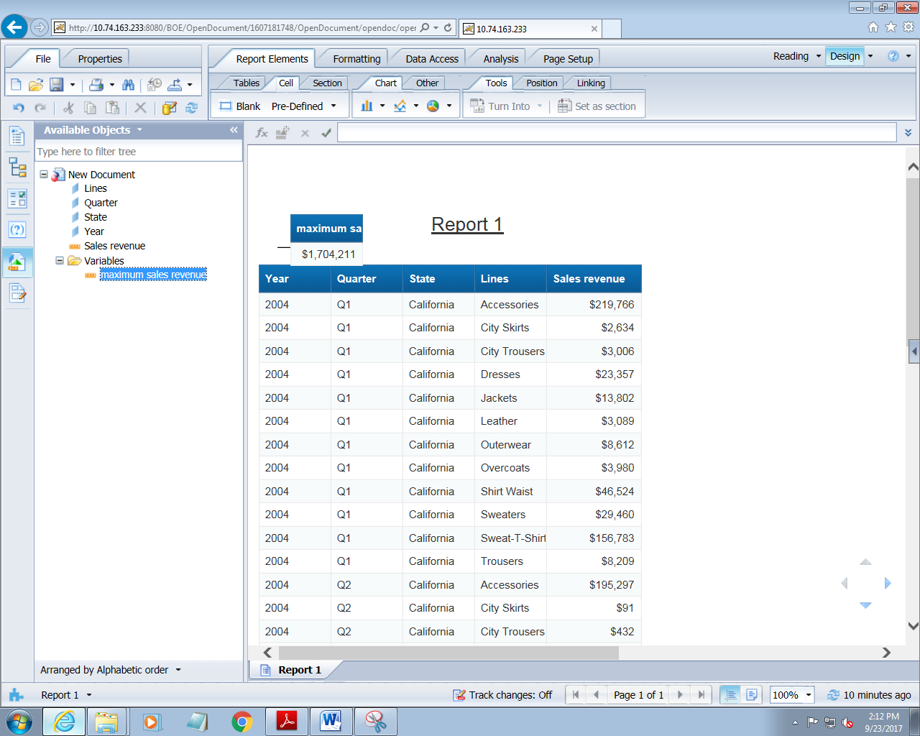

**11.2 CREATE A FORMULA WITH A FUNCTION**

1. Create a new report with the dimensions as

Year, quarter,state,lines,sales revenue



1. Add two filter

Year and sales and select the prompt option to get the value



1. On clicking on run query, following window will appear for entering the value for year and state



1. Drag blank cell on to the report



1. Now click on edit the formula

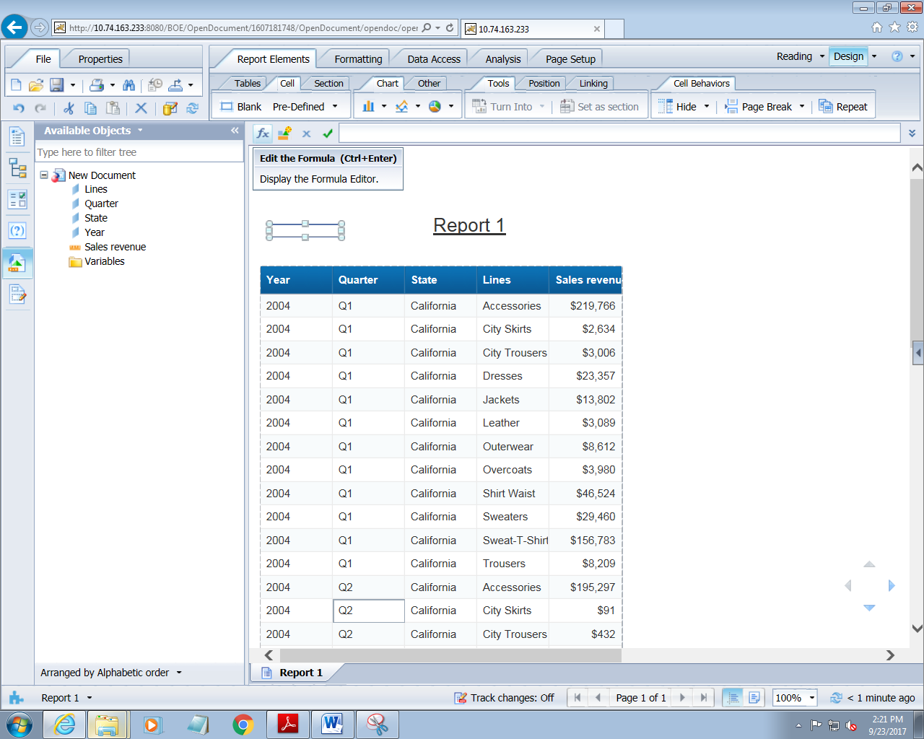

1. On clicking on it

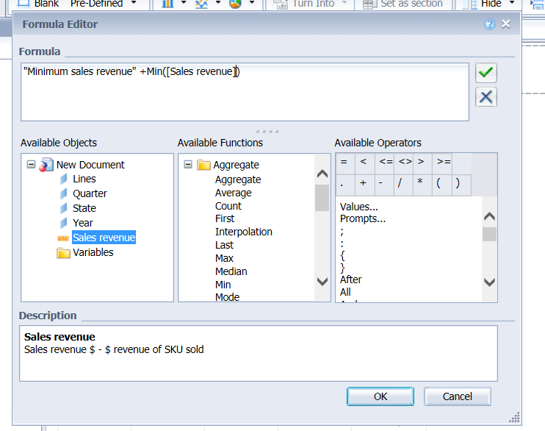

Click on ok and see the report

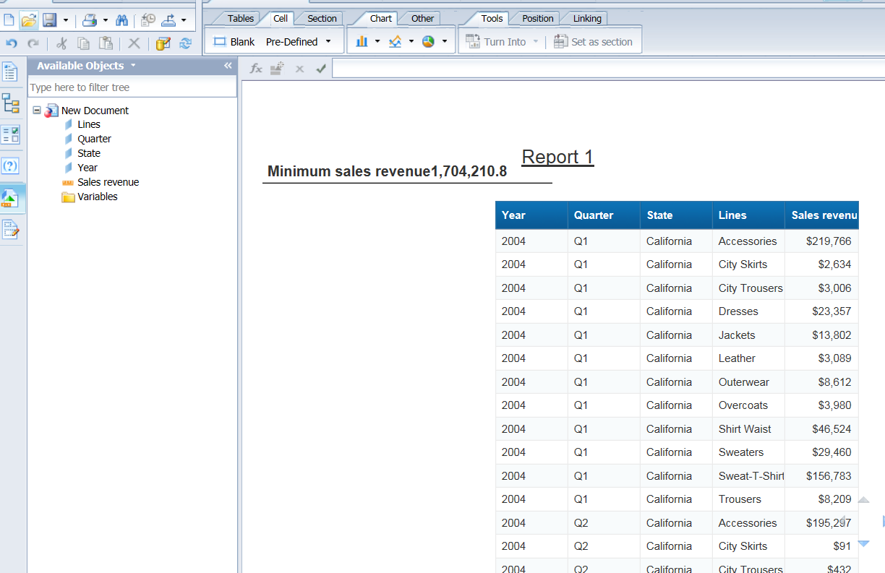

1. **ANALYZING THE DATA USING DRILL MODE**
2. Create a report with the dimensions as

Time and sales revenue

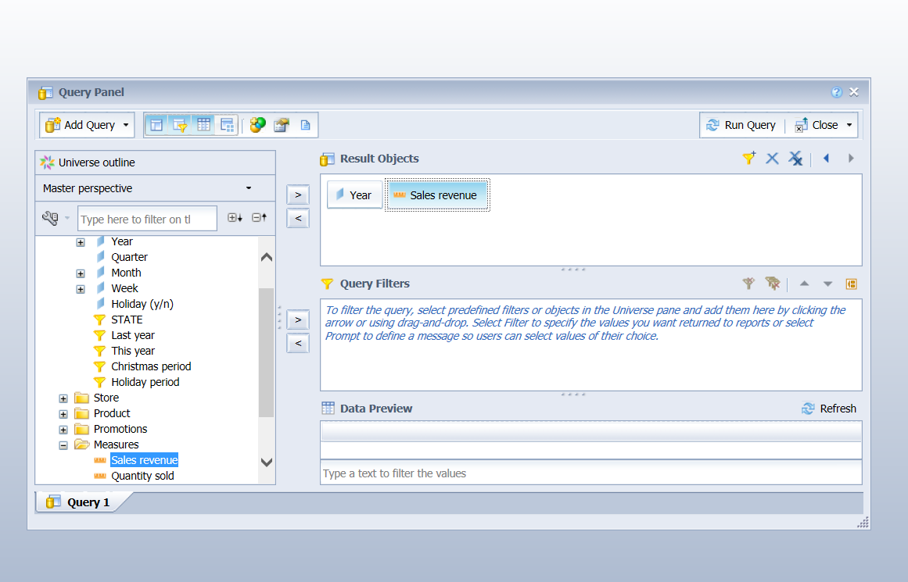

1. Click on run query

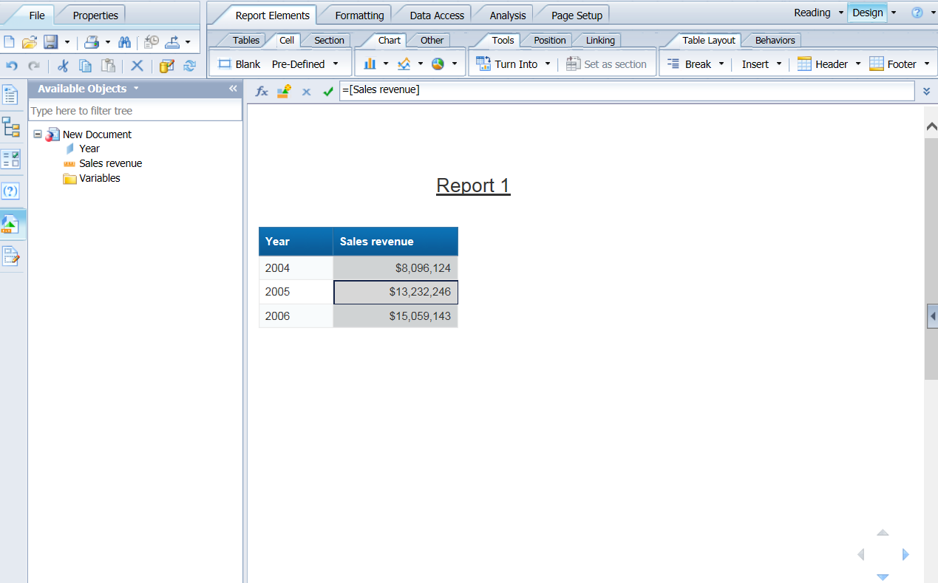

1. Click on drill that is available on toolbar

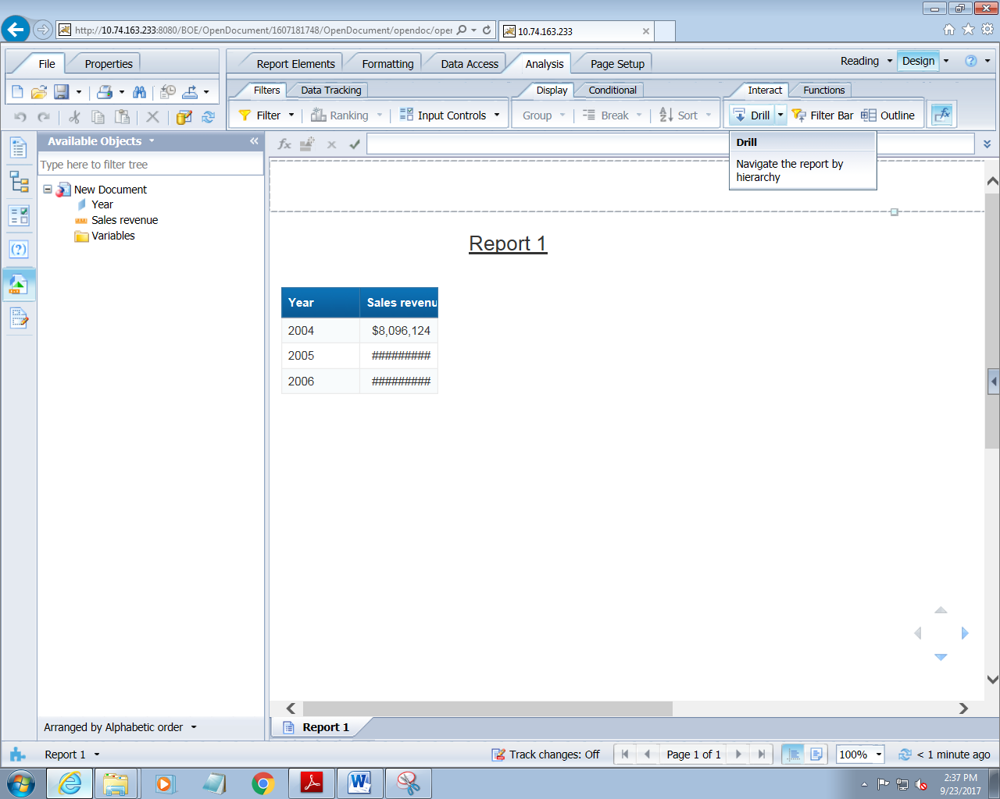

1. Select year 2004 and see the change

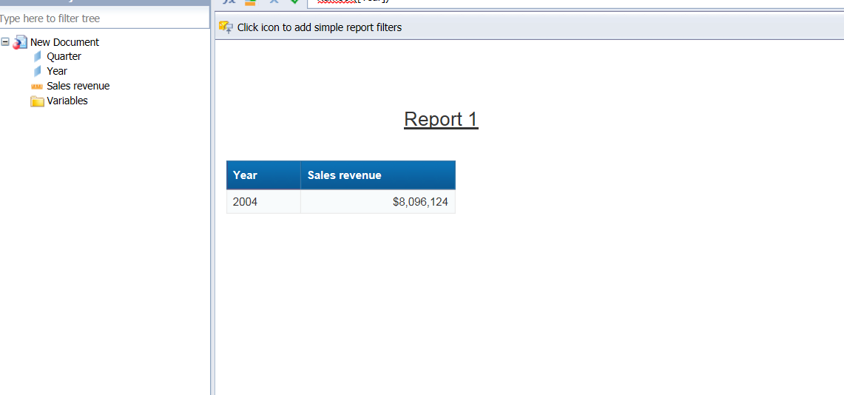

1. Now drill down to quarter and then to months

See the result now

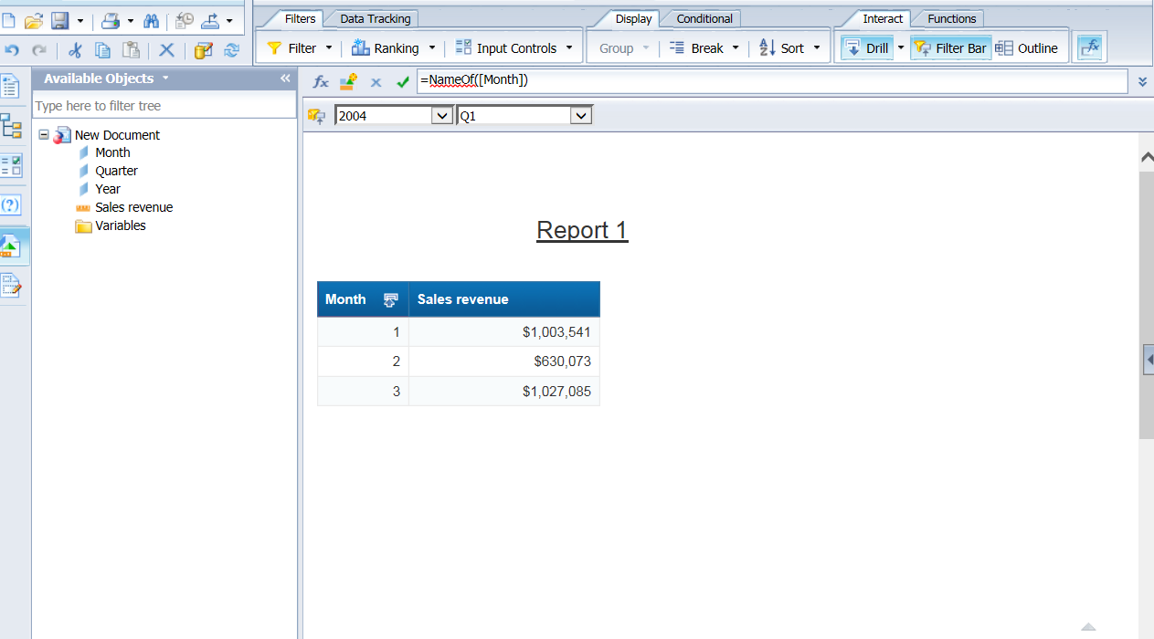

**SCOPE OF ANALYSIS PANE**

1. Go to data access tab
2. Then go to edit option
3. In edit go to scope analysis pane

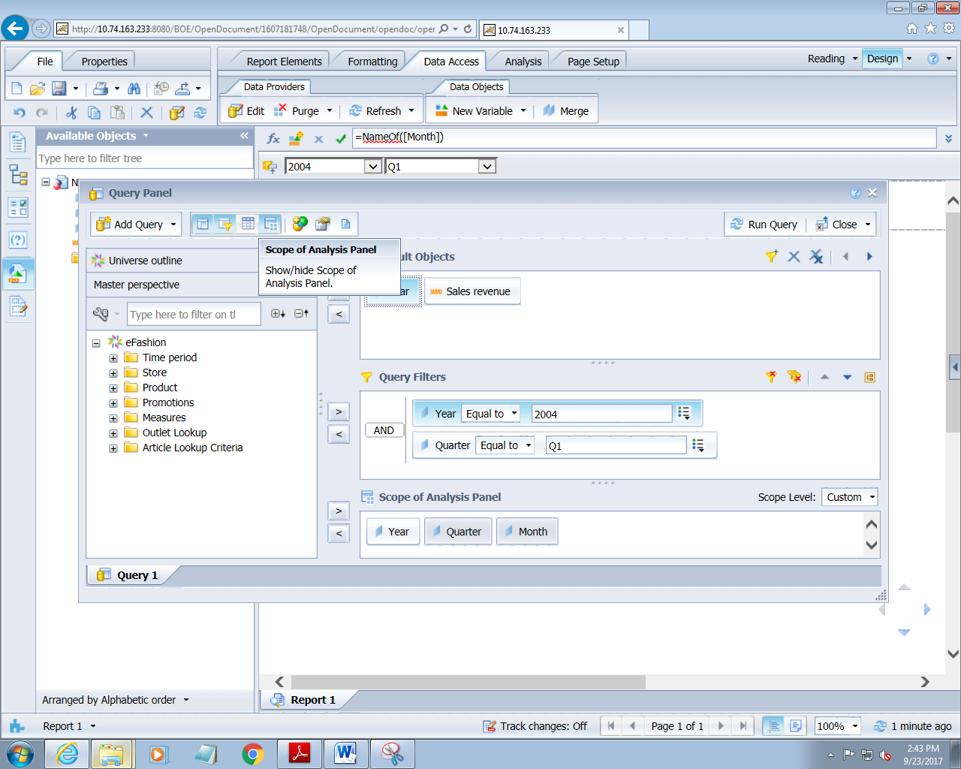

1. Set scope of analysis upto two levels for lines

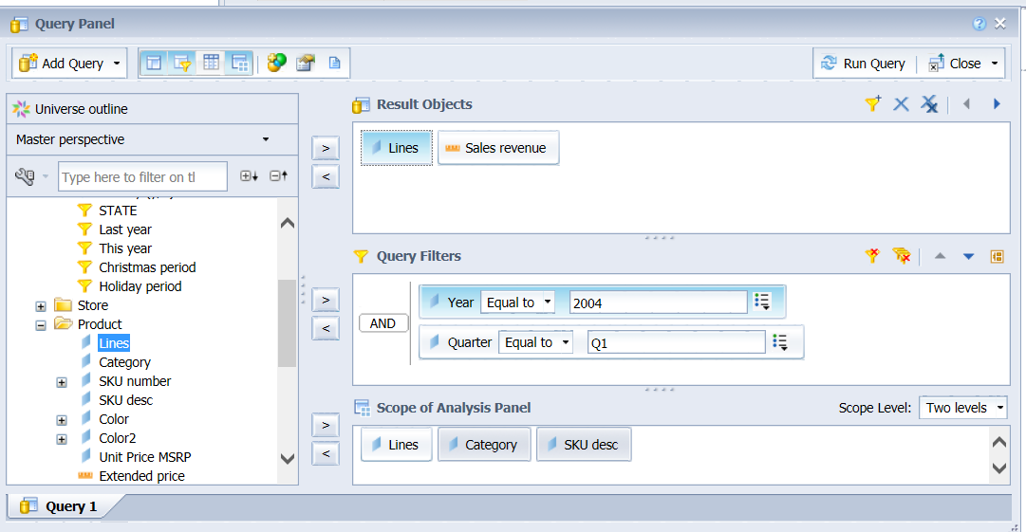

1. Click on run query

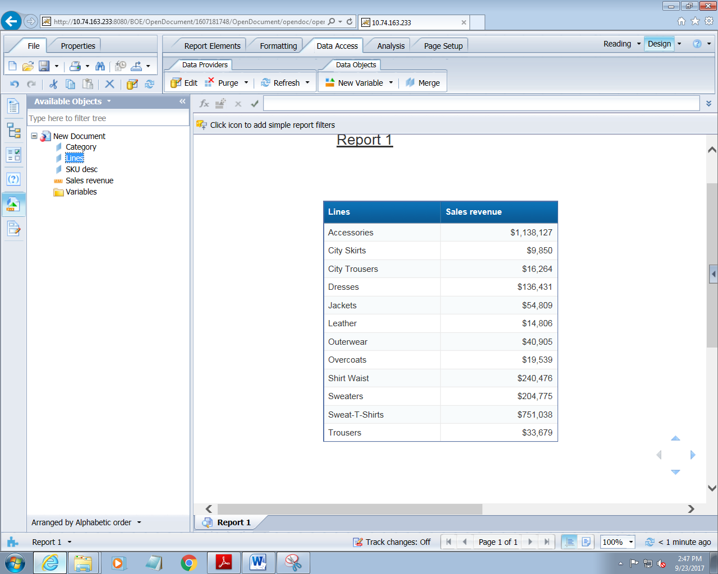

1. Right click on line and select drill by

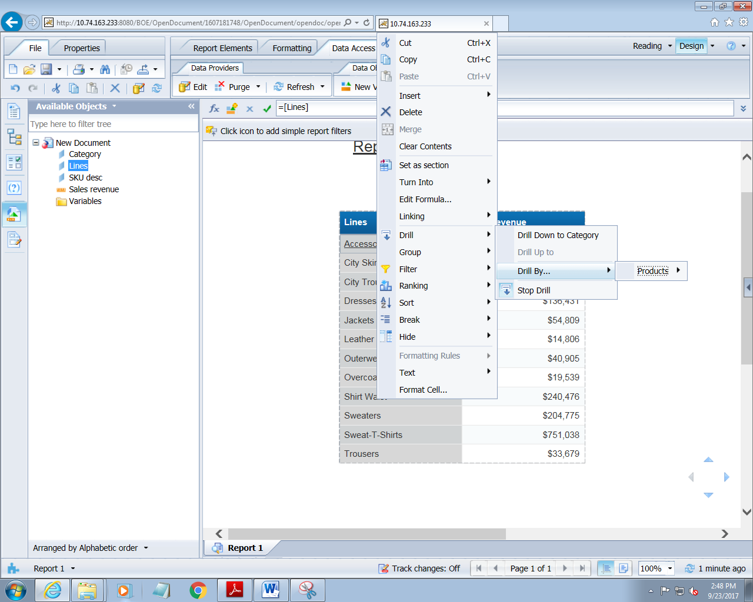

1. See the report now

